# Introduction

This assignment will give you hands-on experience while learning about the fundamentals of cloud computing using the Microsoft Azure platform. You will set up an Azure account and create and deploy a web server, database server, and SQL databases using the Azure Portal.

This assignment is worth 2% of your final course grade.

# Create an Account on Azure

To complete this assignment, you must first create a Microsoft Azure Account. By providing your Seneca College email you will be able to access the required services for free. You will also receive a $100 credit towards other services you may want to take advantage of.

Please visit <https://azure.microsoft.com/en-us/free/students/>to create a new account.

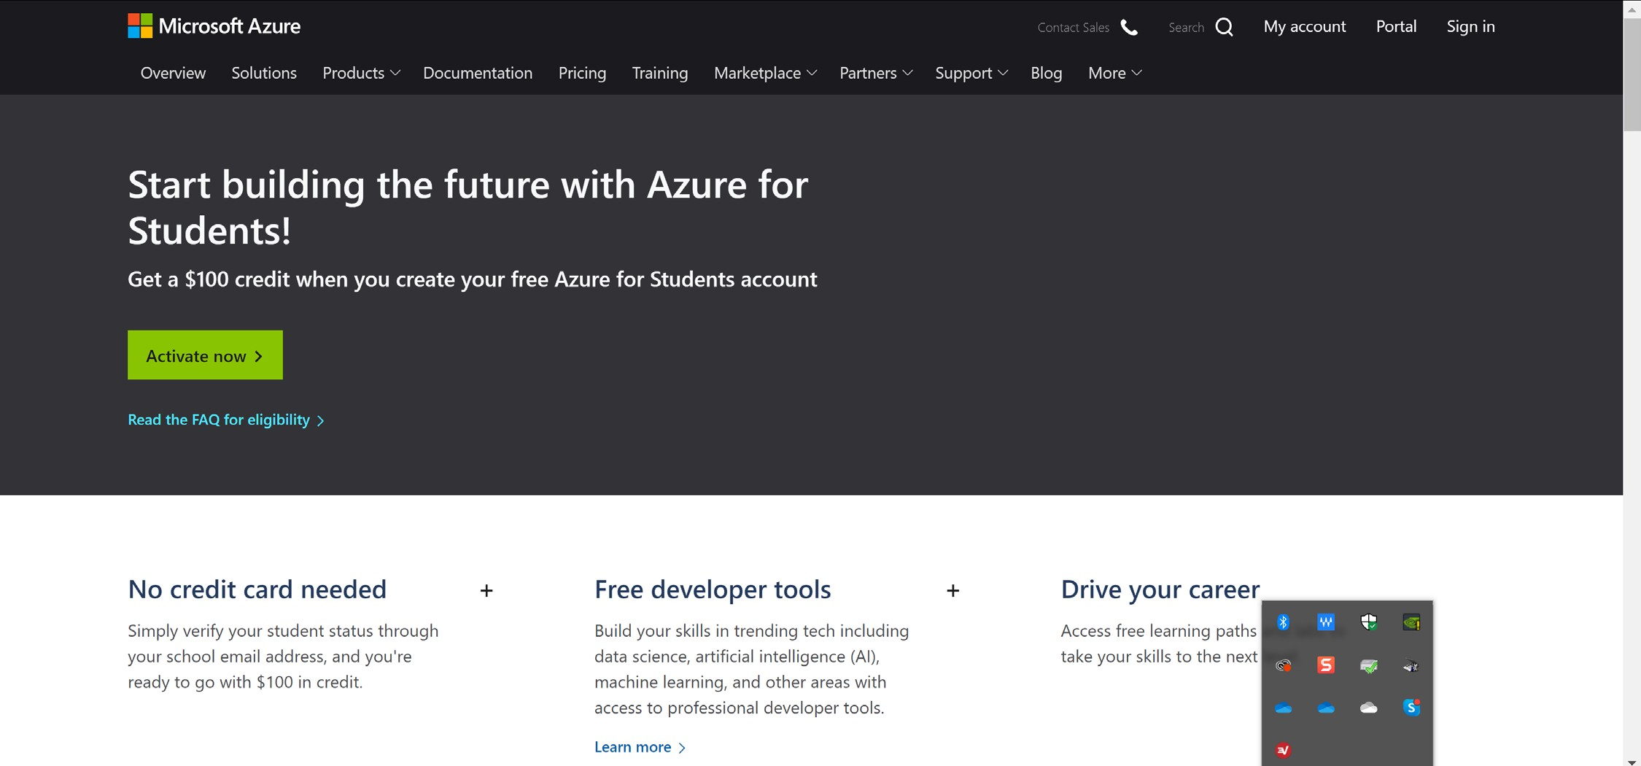

Click “Activate now >” to get started. Following the prompts to sign up for a new account. You may need to use a Microsoft account to sign up. Once signed up, you can activate the “Azure for Students” account. Ensure you sign up for “Azure for Students” and not “Azure for Students Starter”.

Since your professor is unable to follow these steps, you have been provided with images to outline the process. If you are stuck or have questions, please ask for help.

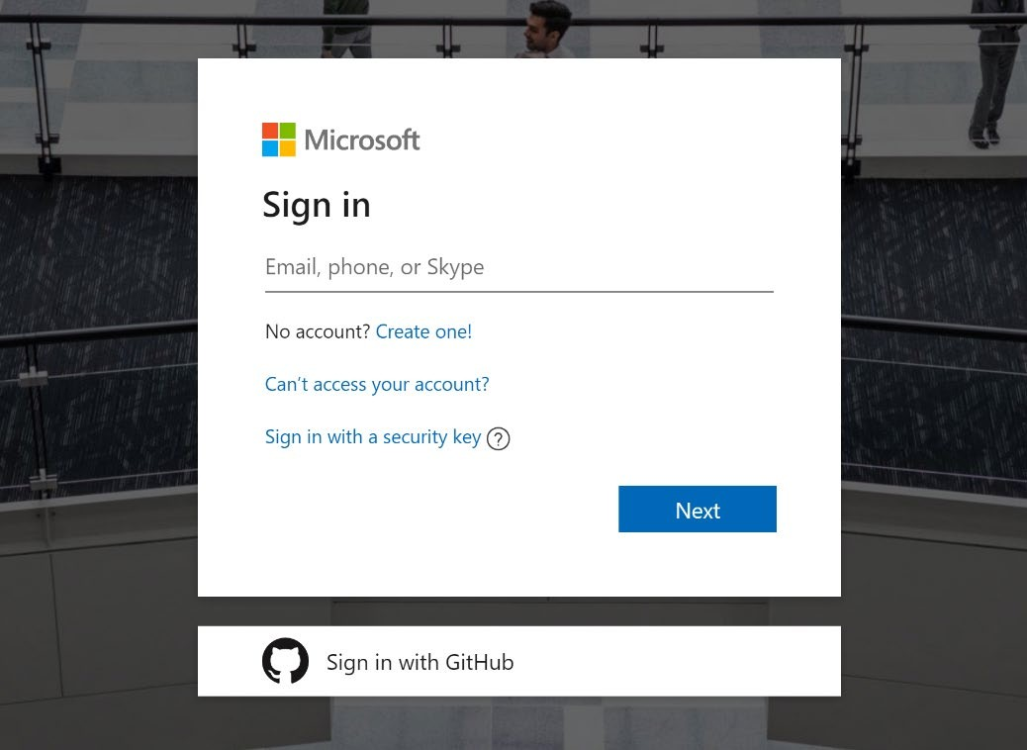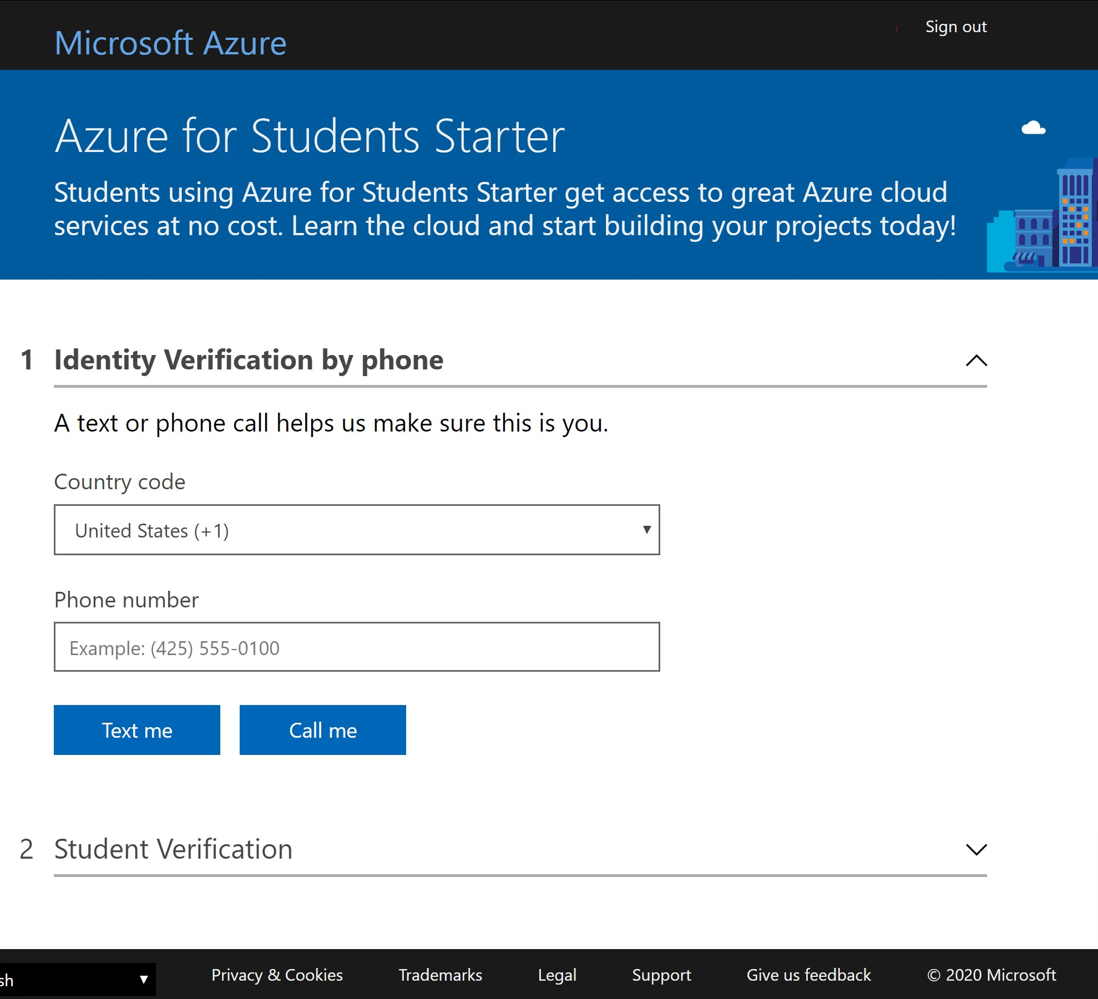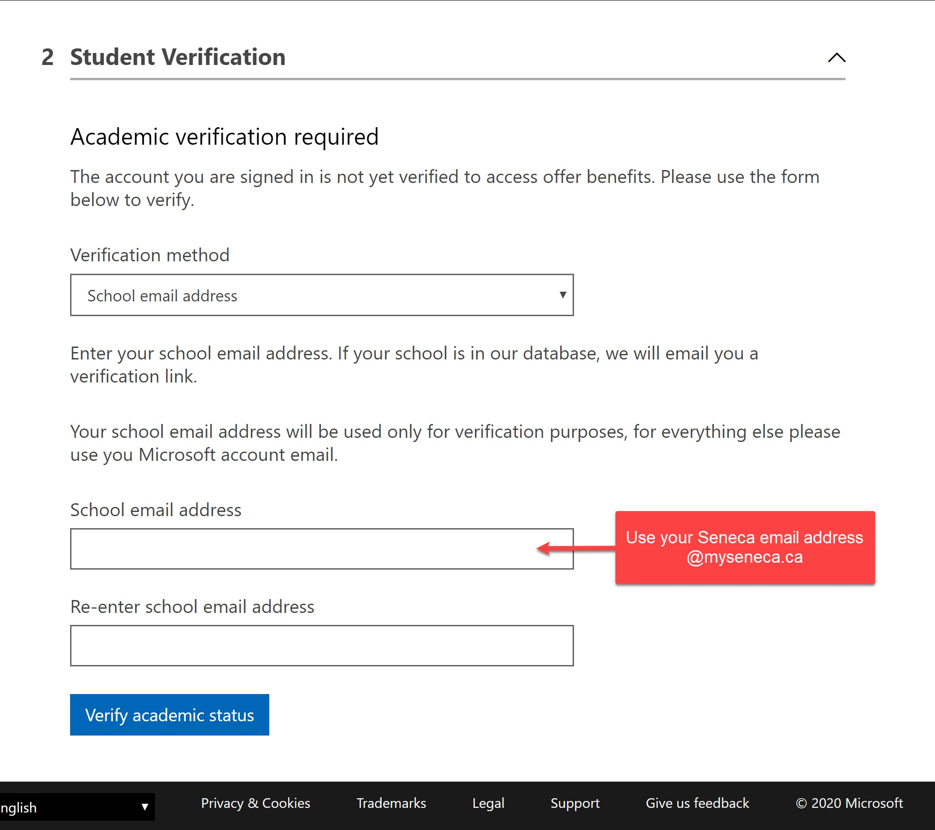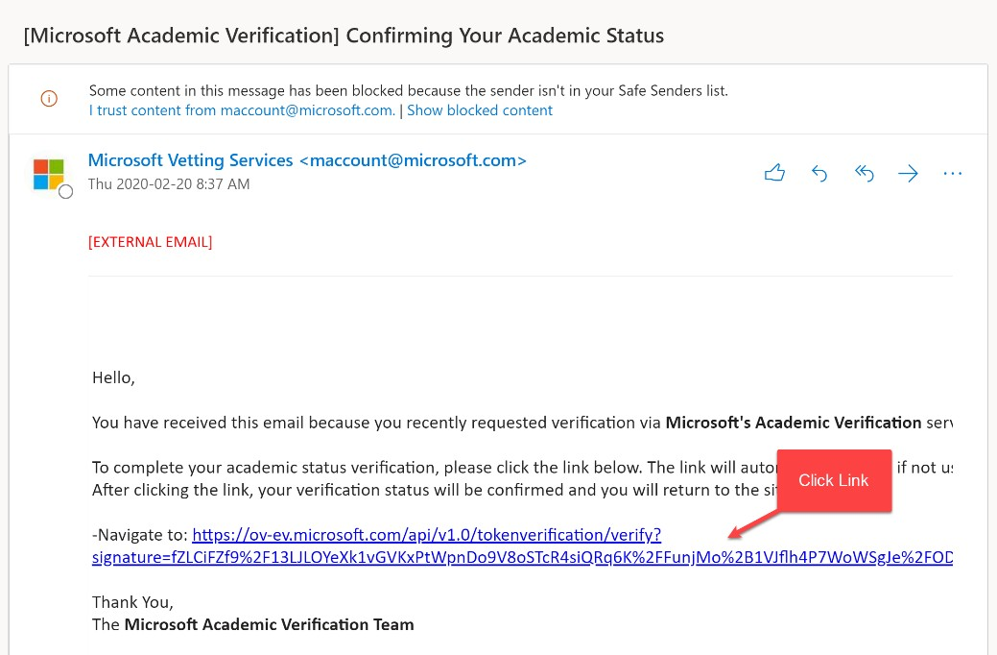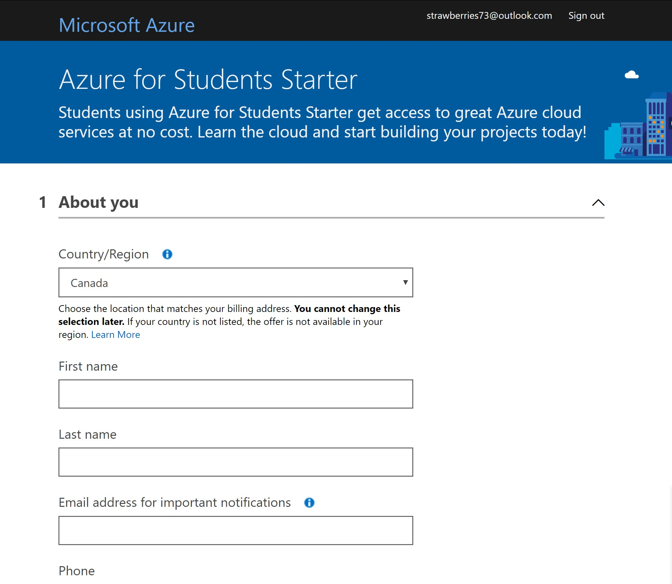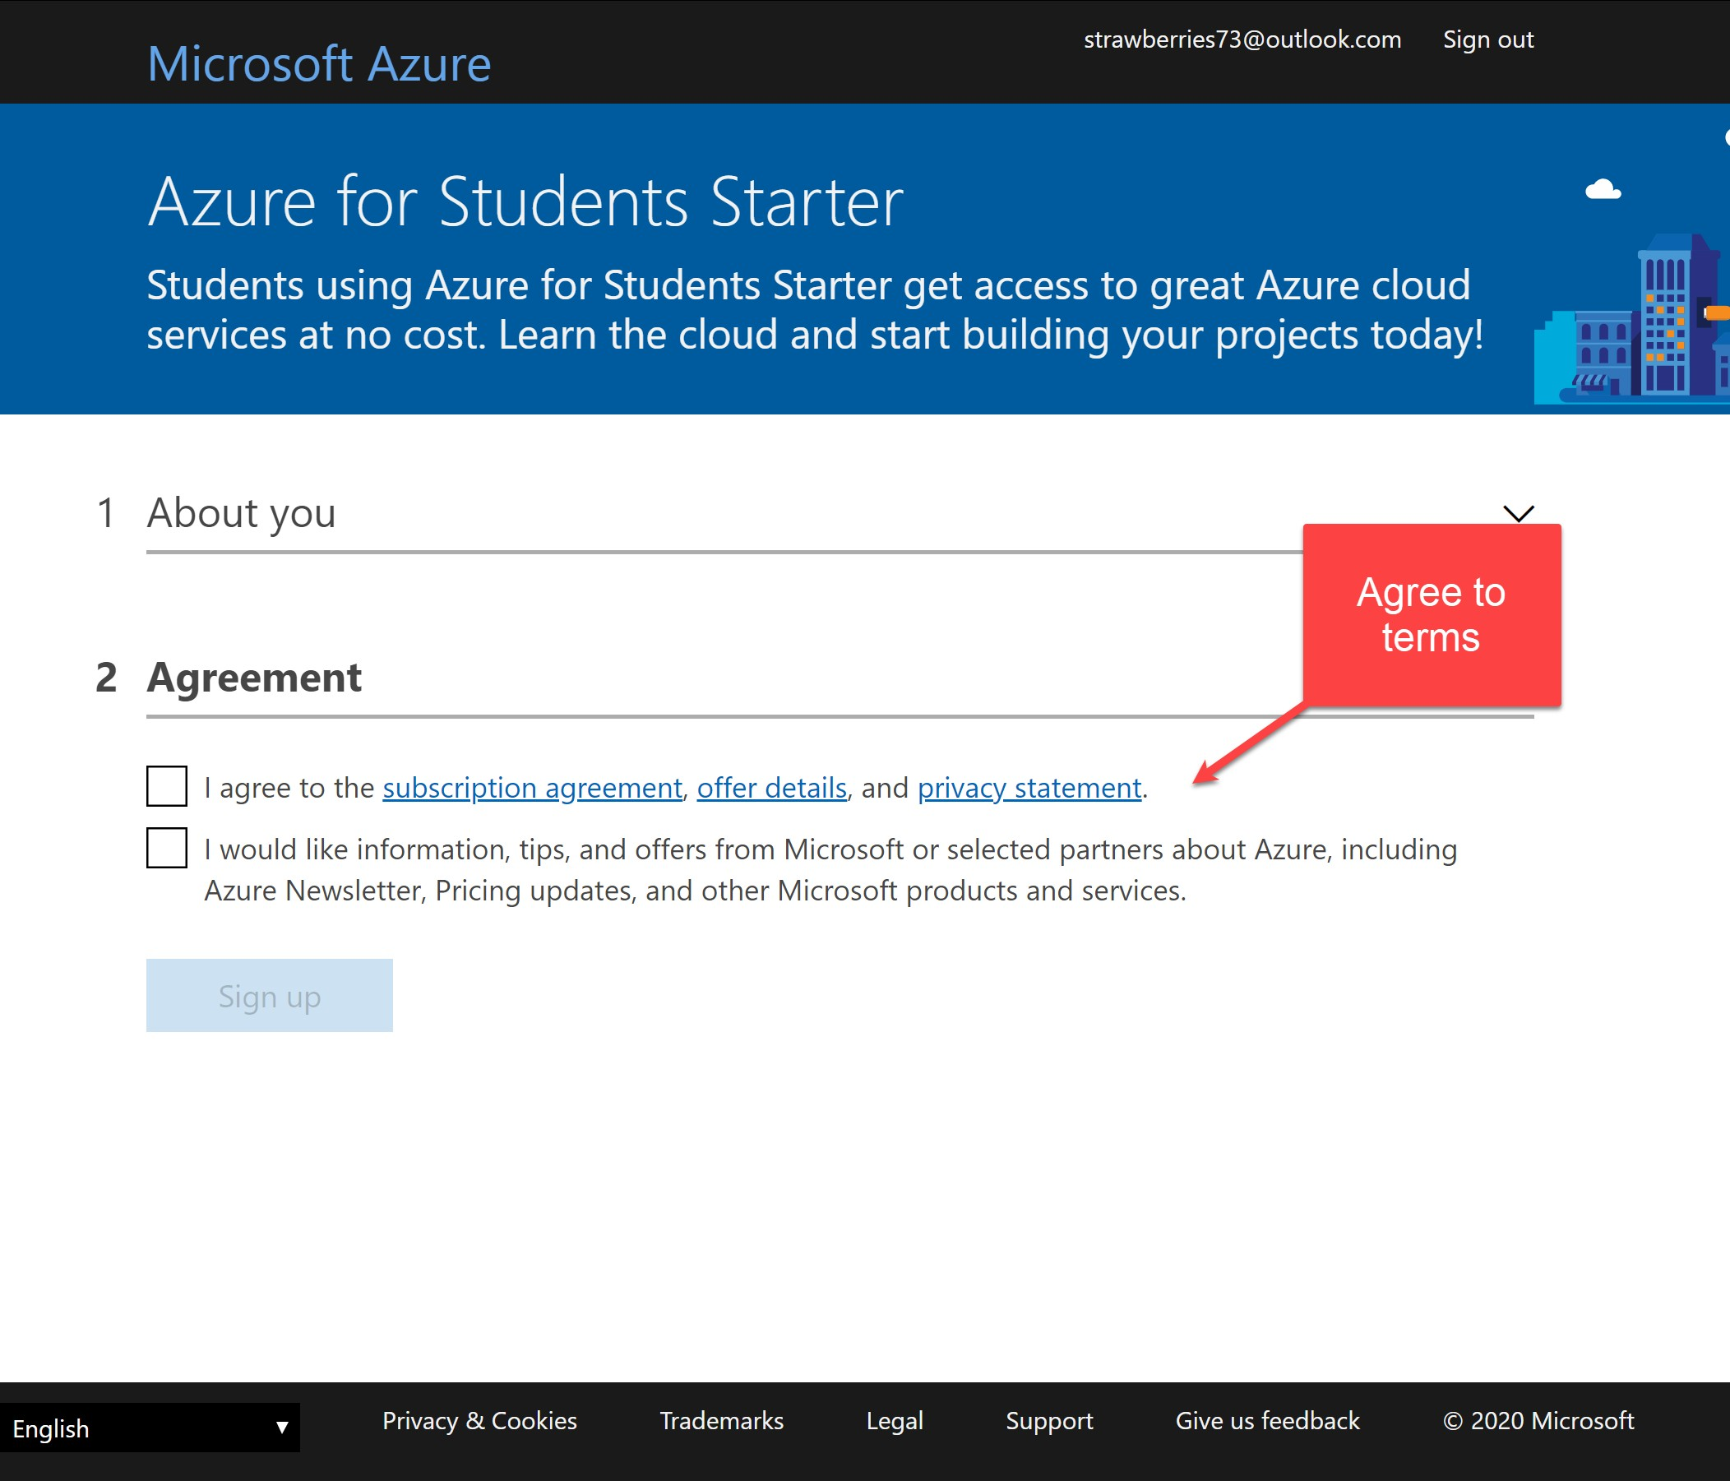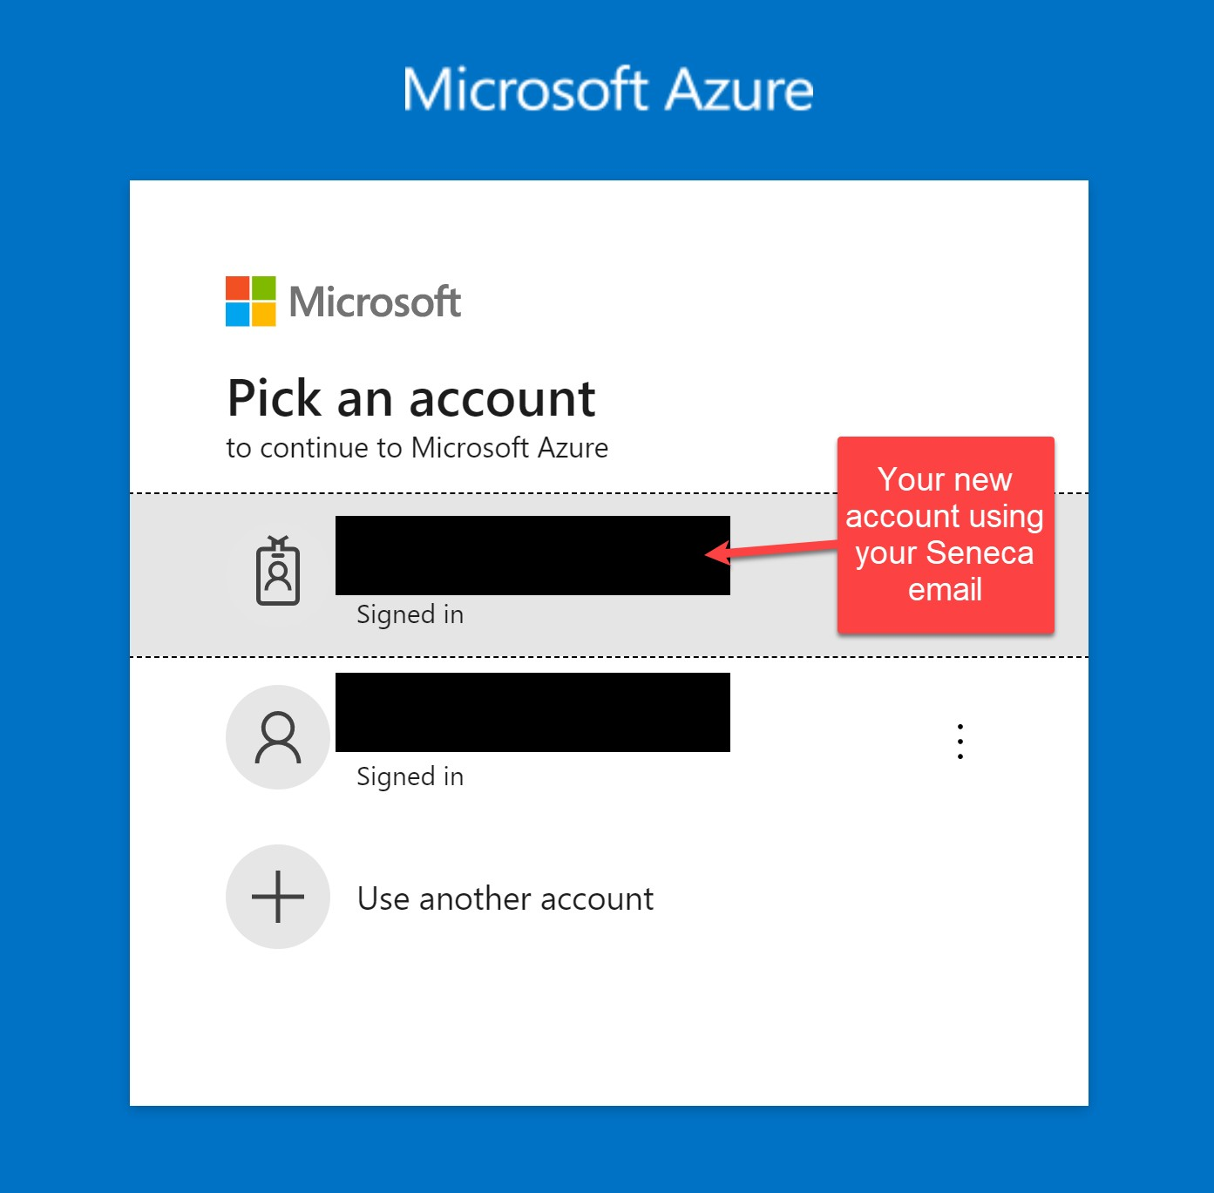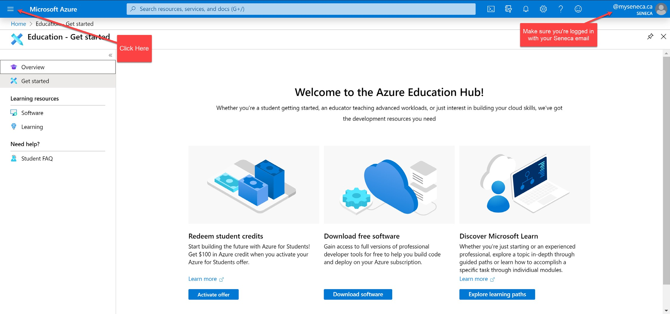

# Verify Your Account

Verify that you can access Microsoft Azure, in other words, make sure you have successfully set up the “Azure for Students” subscription. Login to the Microsoft Azure management portal, using your Seneca email: https://portal.azure.com.

Click the “All services >” item from the menu (near the top-left area of the browser), then choose “Subscriptions”.

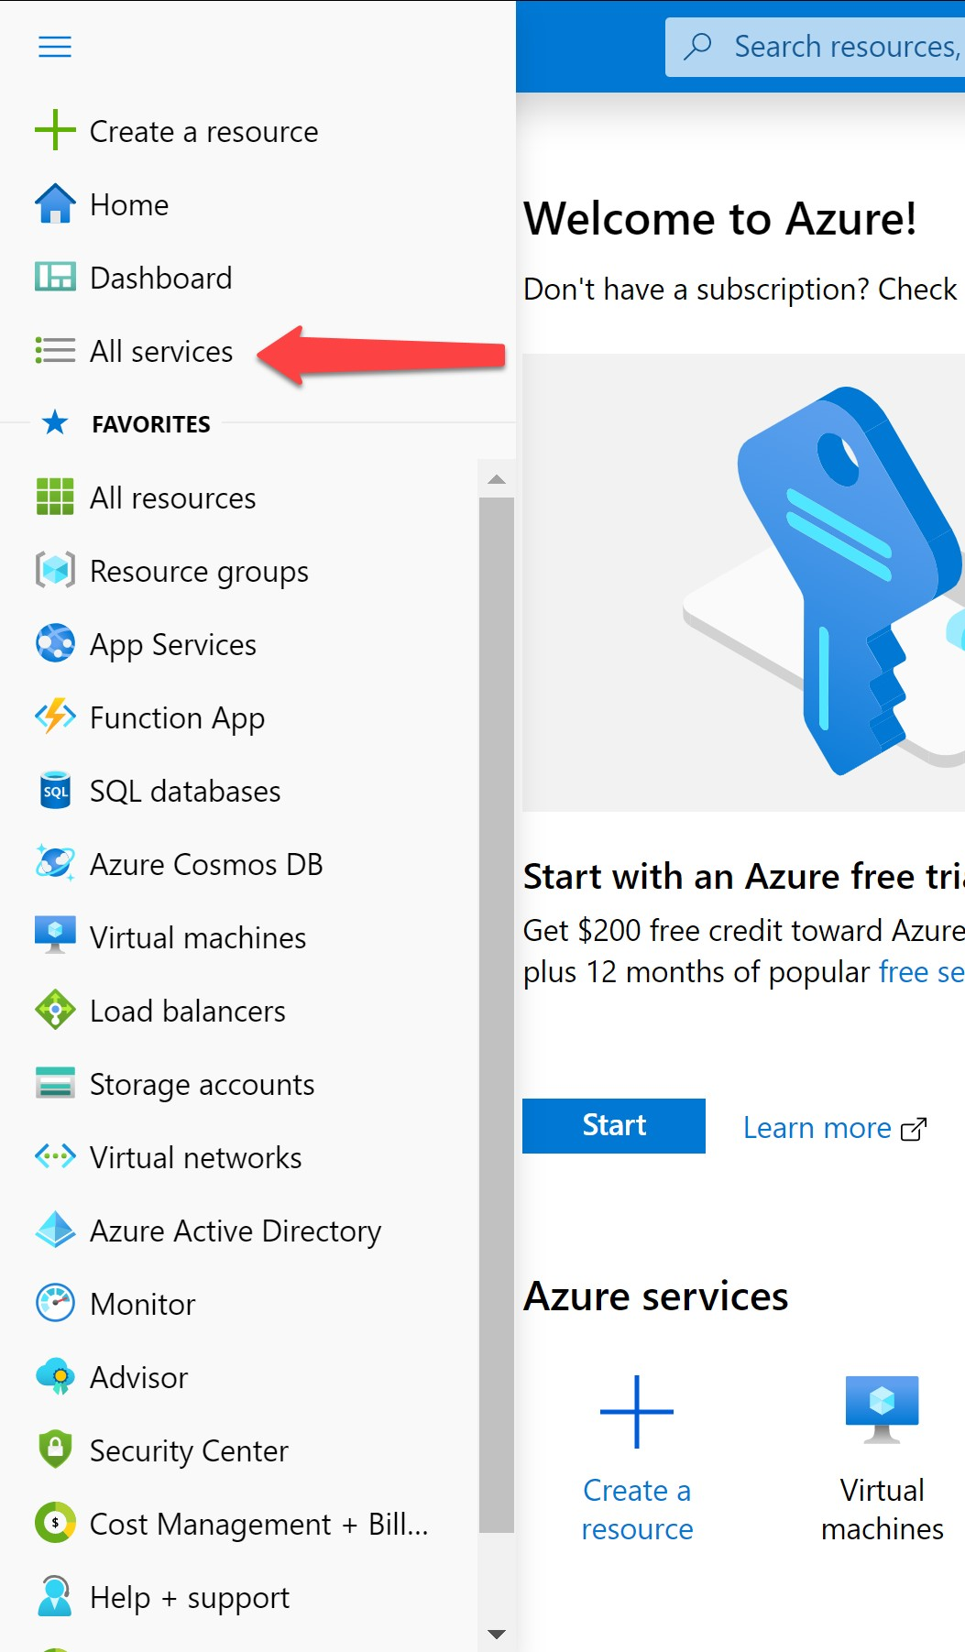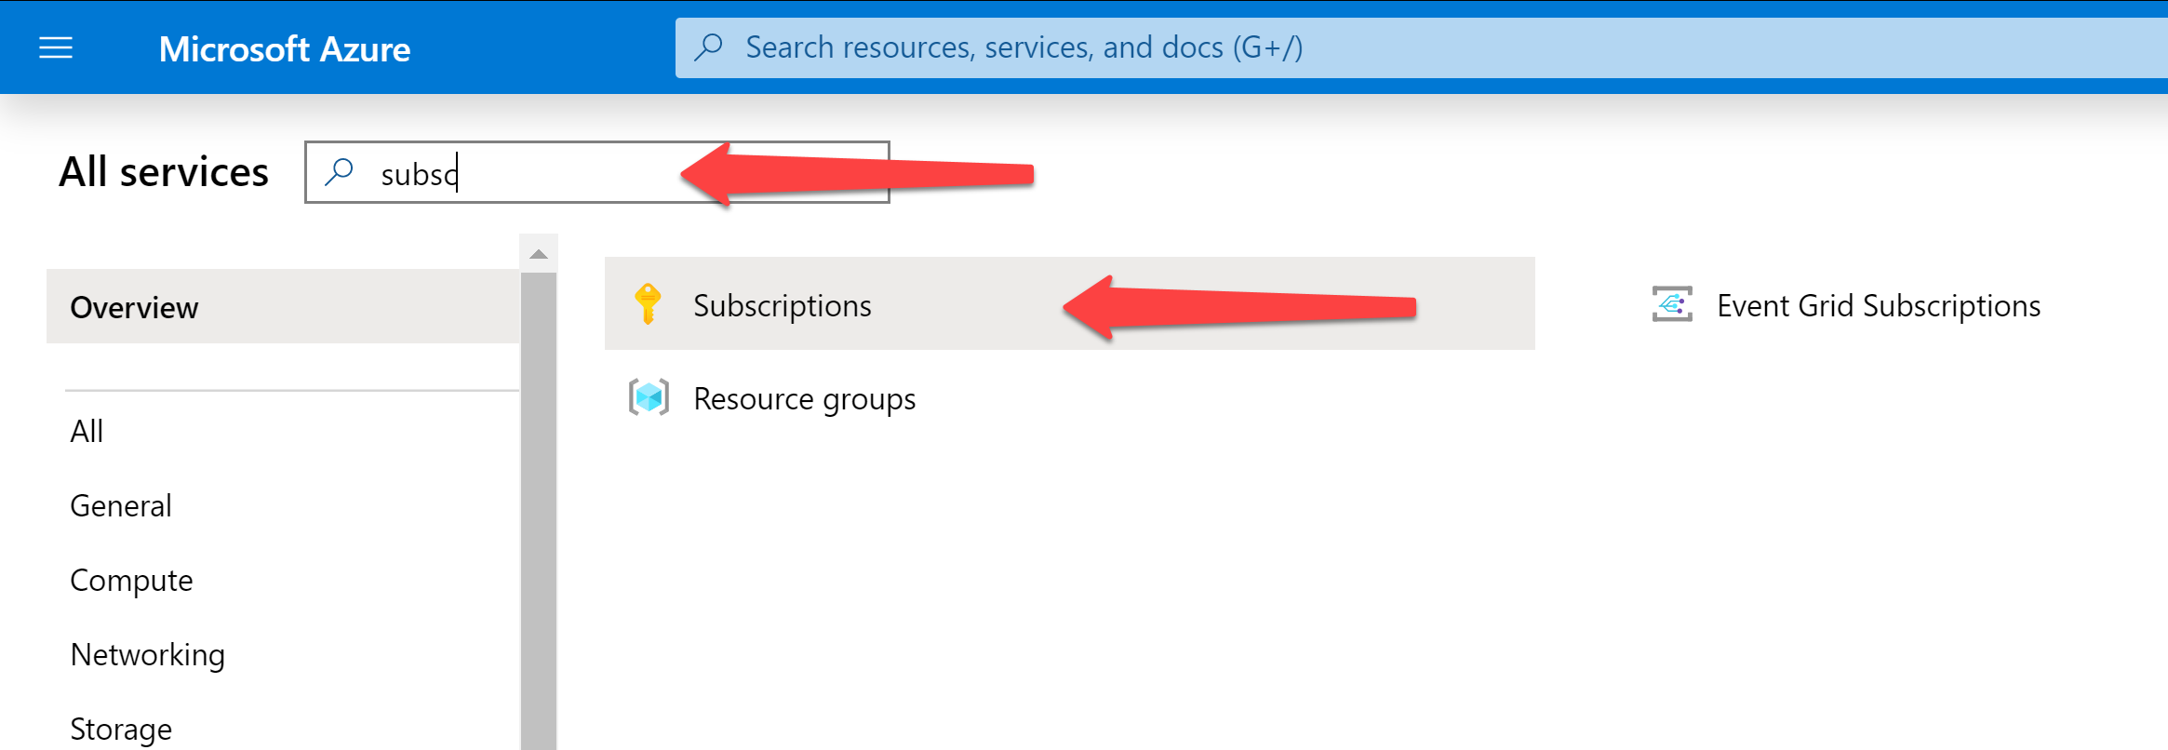

If you see the subscription “Azure for Students” with the status “Active” then you have successfully obtained a subscription for accessing Microsoft Azure.

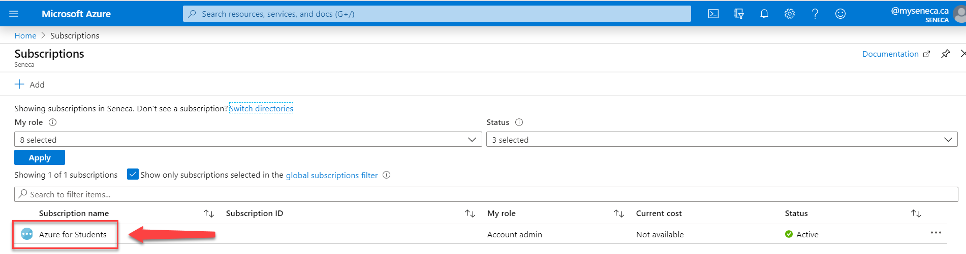

# Planning to use Microsoft Azure services

For this course, we will use “Microsoft Azure Web Apps” and “SQL Databases”. You will name each service you setup so that the name combines your MySeneca Learn ID with the course information. Carefully read the following guidelines and name your services exactly as instructed. **In the examples below, “nromanidis” is my Seneca Learn ID, you must use your Learn ID, not mine.**

## Database Server

A database server is a SQL Server deployed on the Microsoft Azure infrastructure. You will only need one database server to host all the databases required to complete your assignments. Name your server: **nromanidis-ds-web524**.

During the creation of the database server, you must create or define credentials. **Make sure you record your username and password in a safe place. You will need this information later. The password should not include a semi-colon or dollar sign.**

## SQL Databases

A database server can hold one or more SQL databases. Each SQL database name will be customized for the assignment you are working on. For Assignment 4 (this assignment), the SQL database name will be: **nromanidis-db-web524-a4**.

## Web Apps

You will create new web apps to complete your Assignments. Each assignment will use its own web app. If you want to create a web app for Assignment 4, then use this web app name: **nromanidis-wa-web524-a4**.

Each web app requires an App Service Plan. Name your plan: **nromanidis-asp-web524**.

# Create a SQL database server and a database

On the Azure portal, click the hamburger icon at the top-left then click **+ Create a resource**.

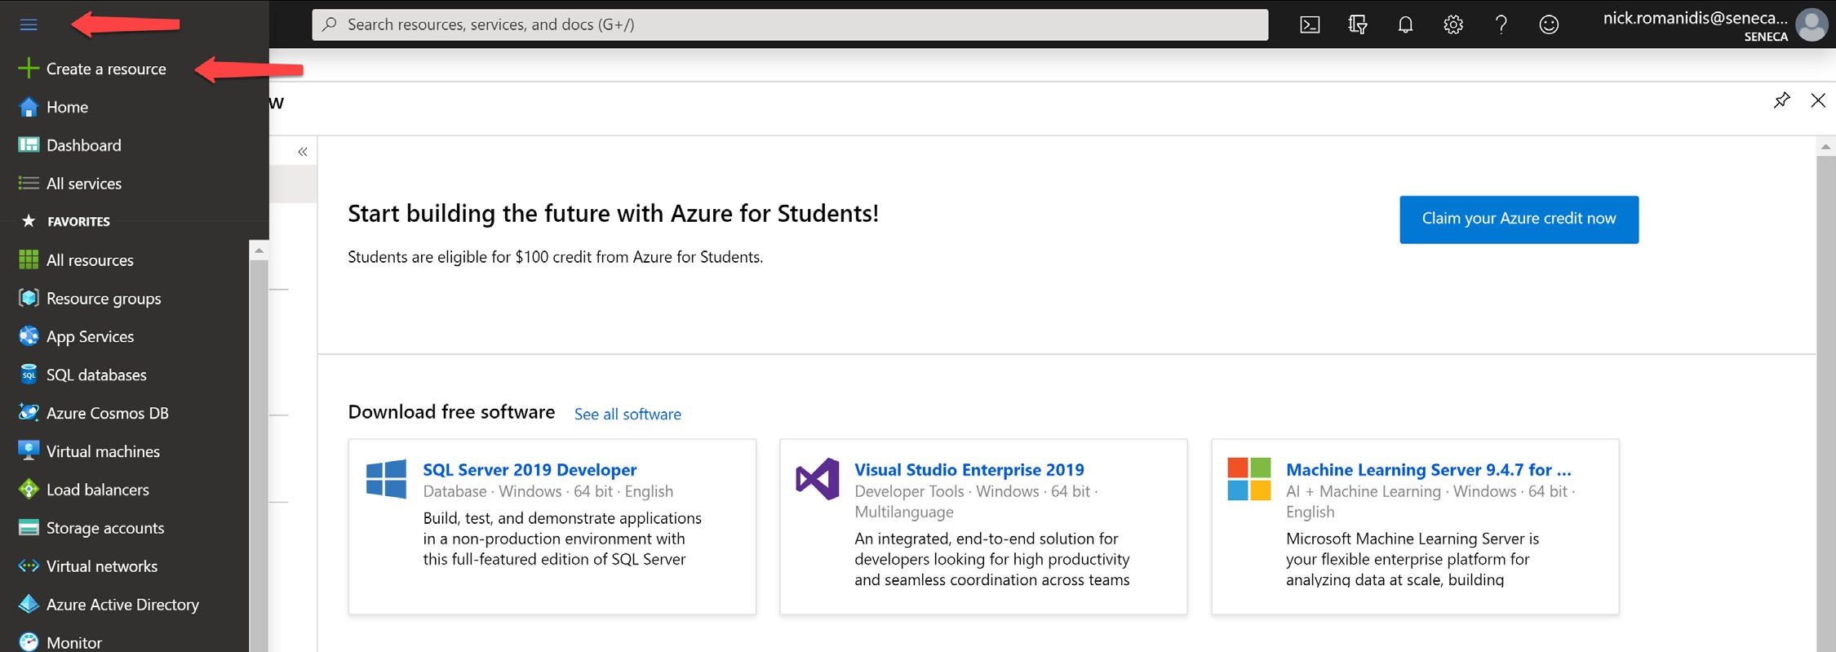

In the search box, type in “SQL” then press the **Enter** key.

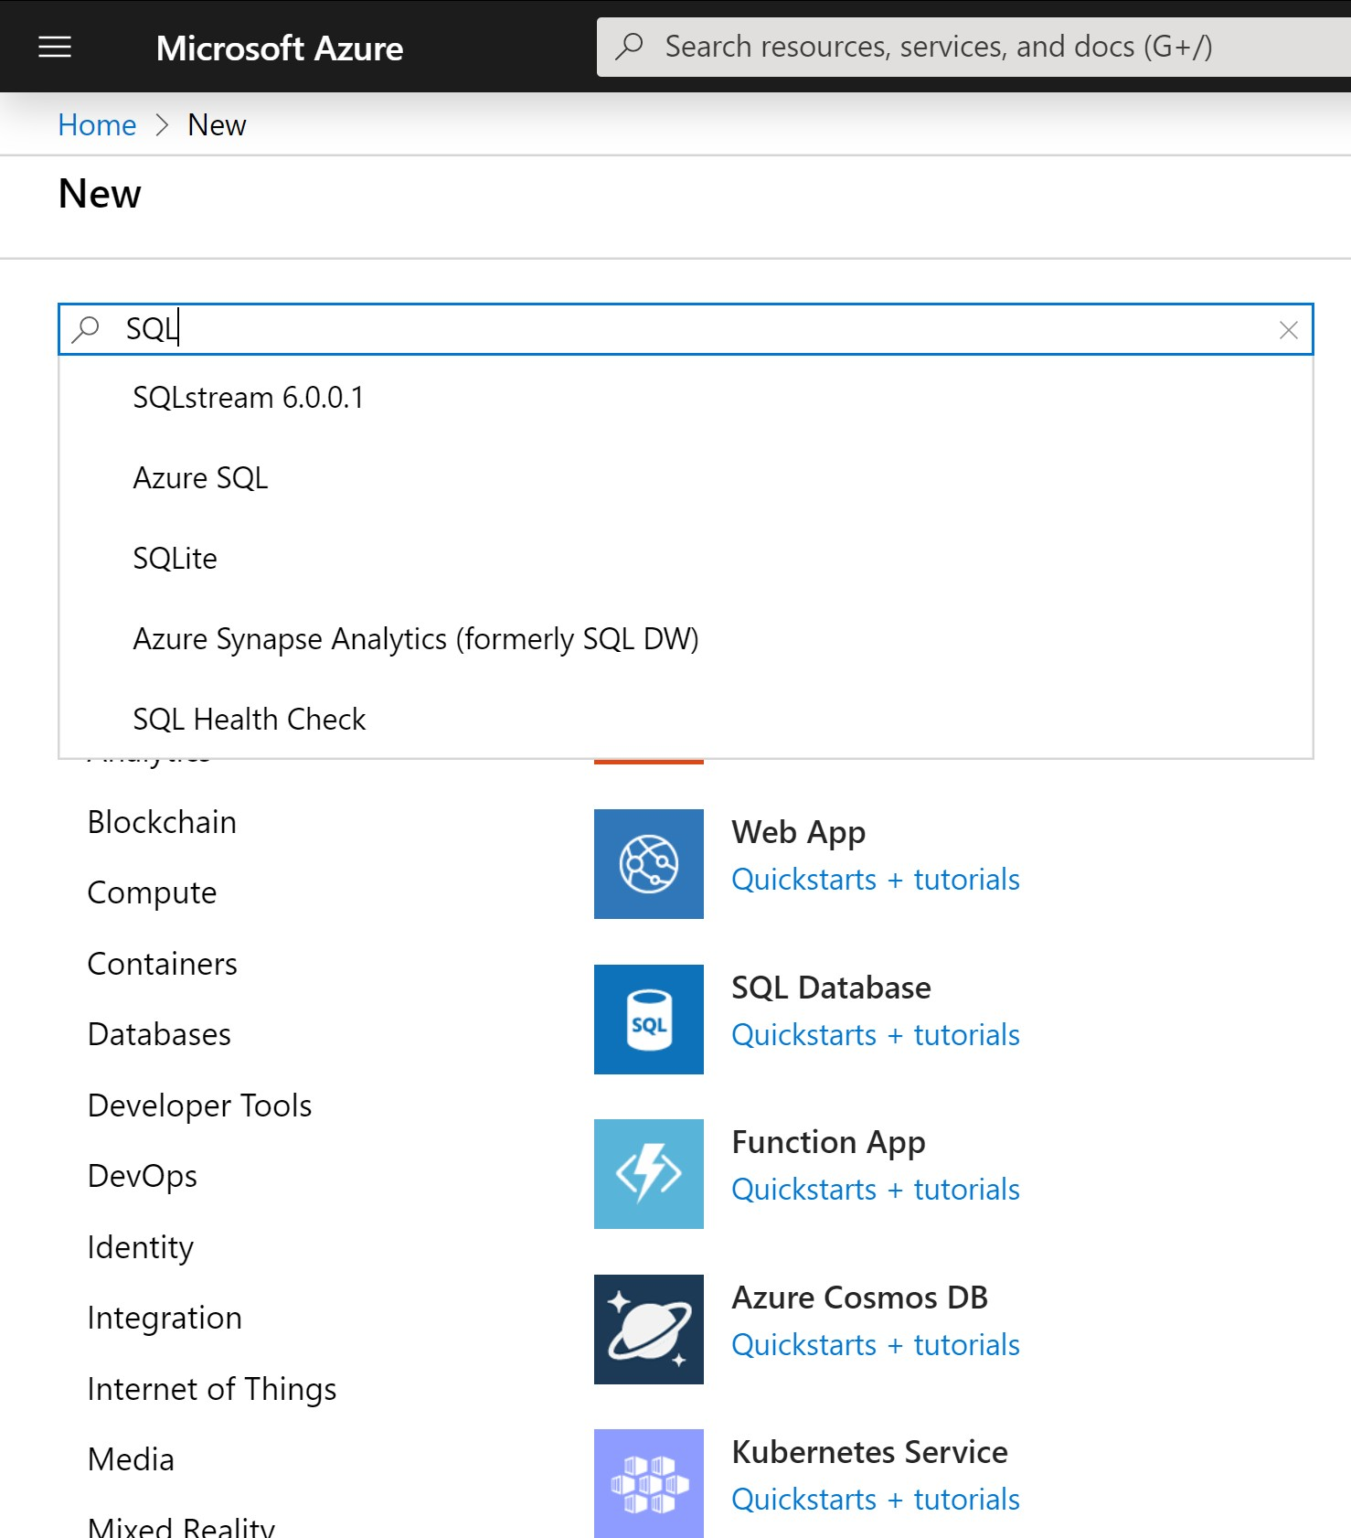

Select **Azure SQL**

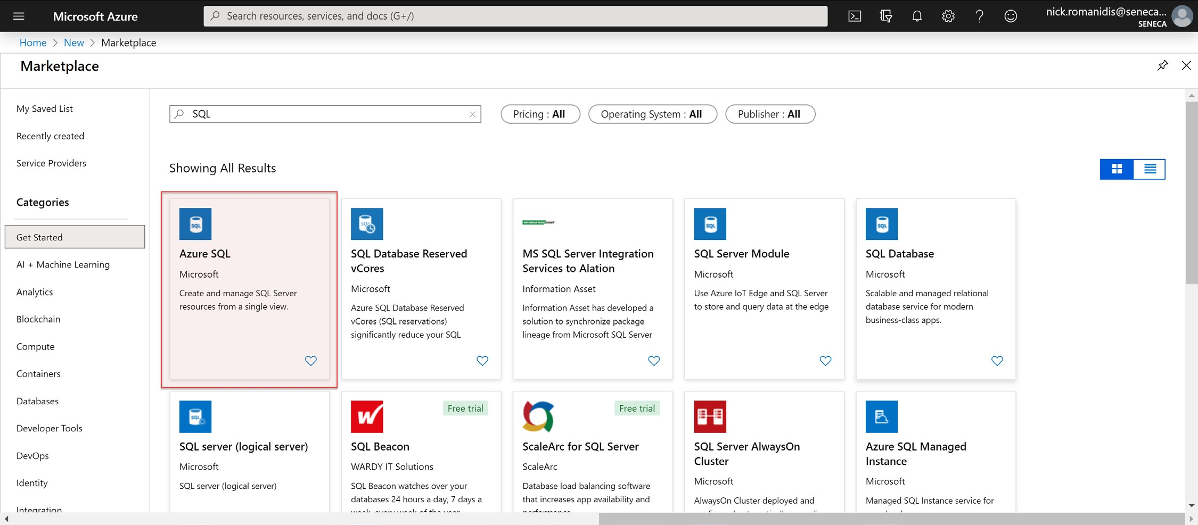

Click the **Create** button.

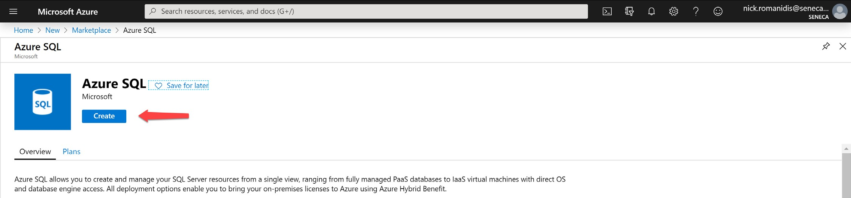

Choose **SQL databases** and select the resource type **Database server**. Click **Create**.

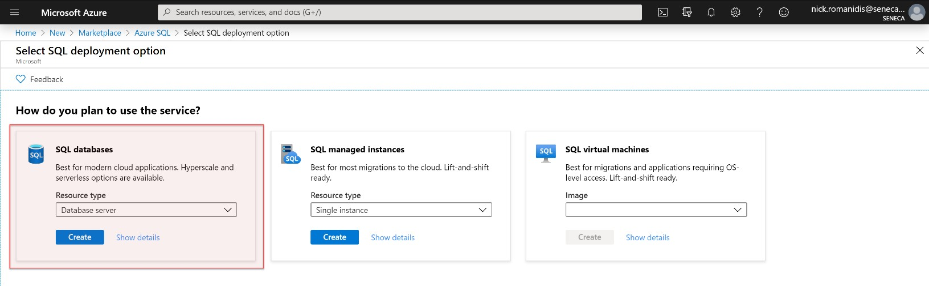

Fill in information about the new database server as per the screenshots below.

For the “Resource group” setting, create a new resource group and call it “WEB524”.

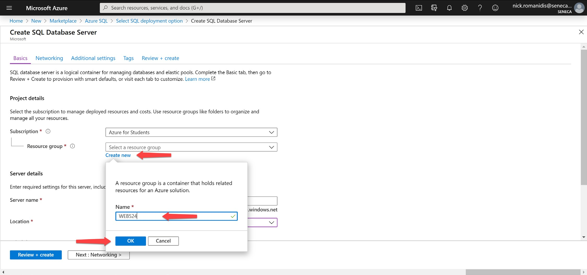

As mentioned earlier, you will use a “Server name” like **nromanidis-ds-web524**.

Change the location to “(US) West Central US”. In a later step, you will create a new web app and you should use the same location for your web app and database server. **Due to a limitation of free Azure accounts, you may have to choose a different location. Try to use the same location whenever prompted, if you cannot, don’t worry, it will still work correctly.**

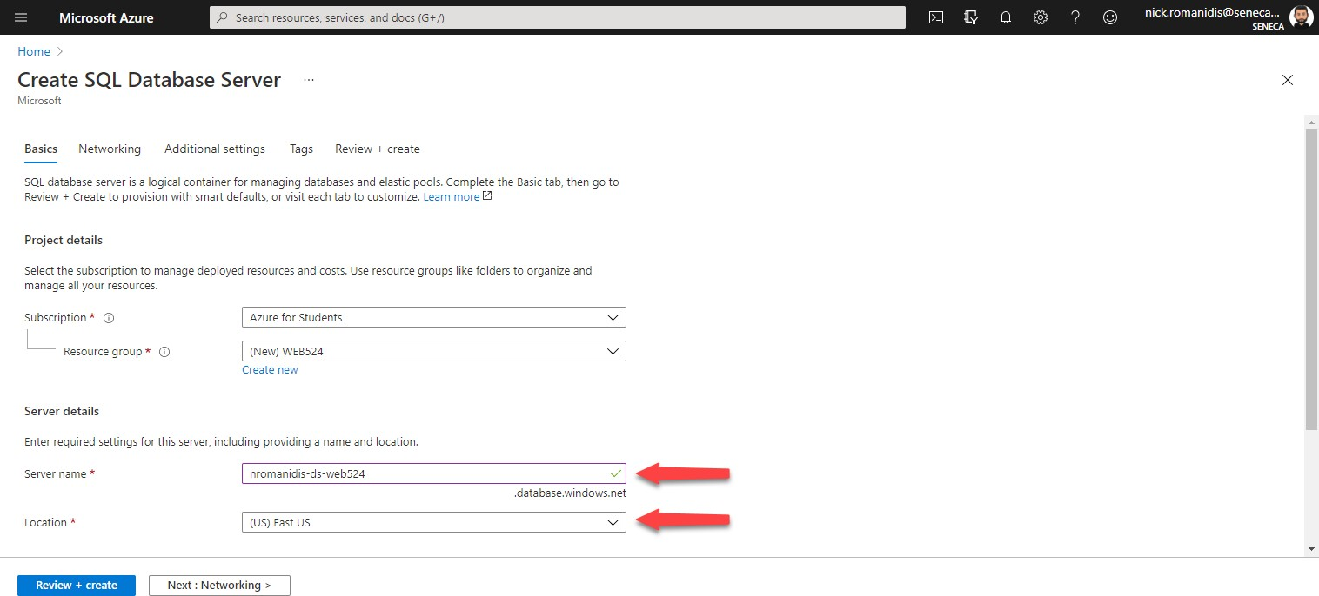

You can use your own “Server admin login”, e.g. **nromanidis** and a password. Please write down the login and password as you will need these later on for setting up the connection to the database.

When done, you will click **Review + create**.

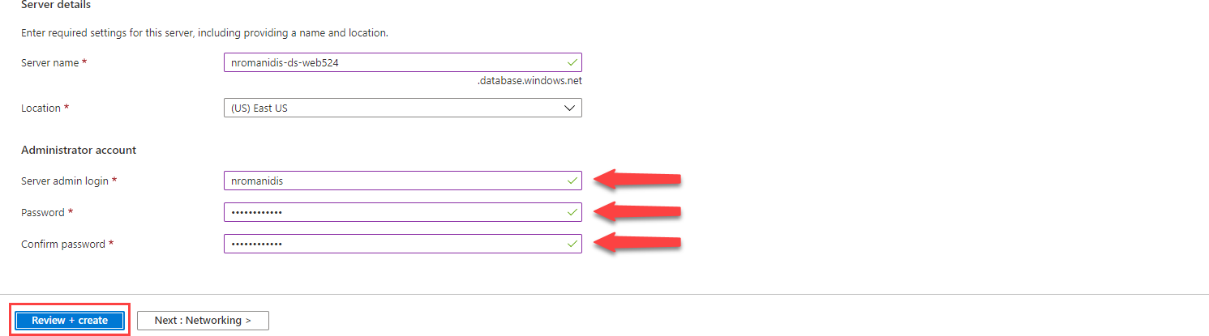

Review the settings you have specified and if correct, click **Create**.

It may take a few minutes to create a new database server. If you want to see the progress, click the bell icon at the top right of the screen.

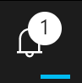

Do not continue until the database server has been successfully created.

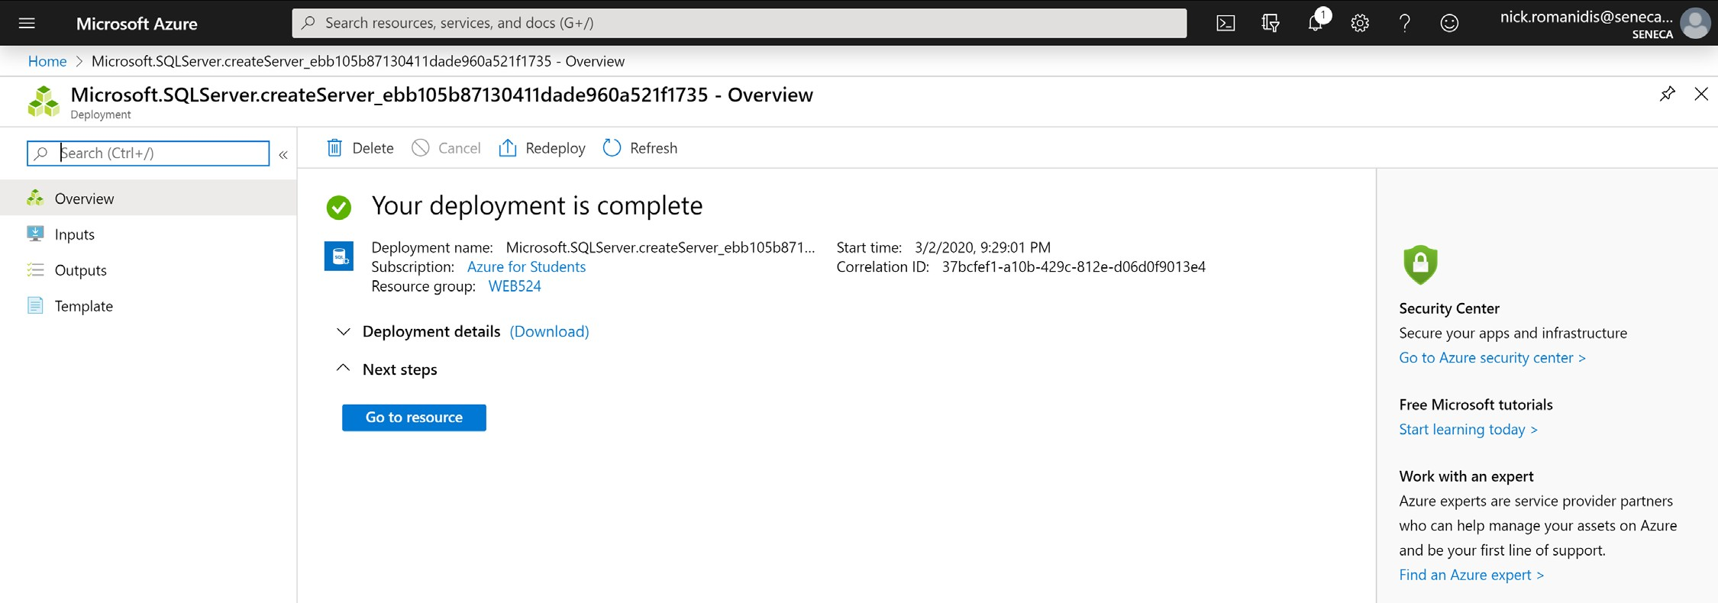

Click on **Go to resource**.

# Create a database

Click on **+ Create database**.

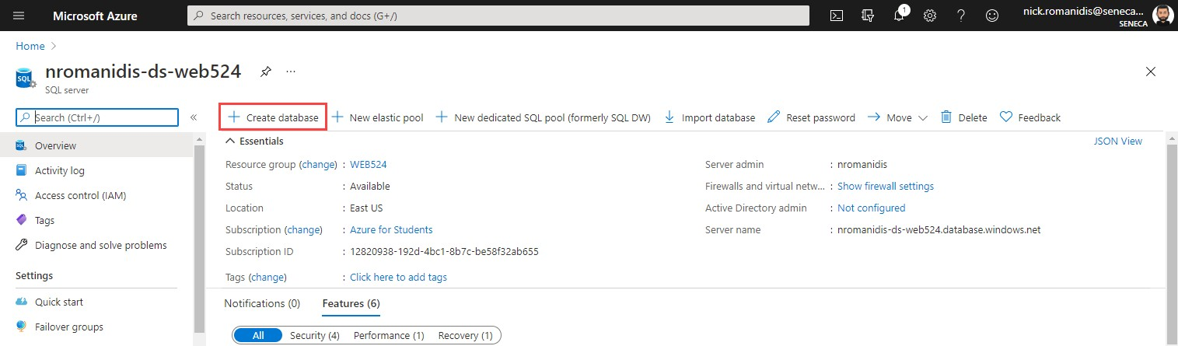

Name the new database according to the guidelines mentioned above. Click on **Configure database** to change the compute + storage size. **Do not forget to change the compute/storage size or you will deplete your entire credit in only a week or two!**

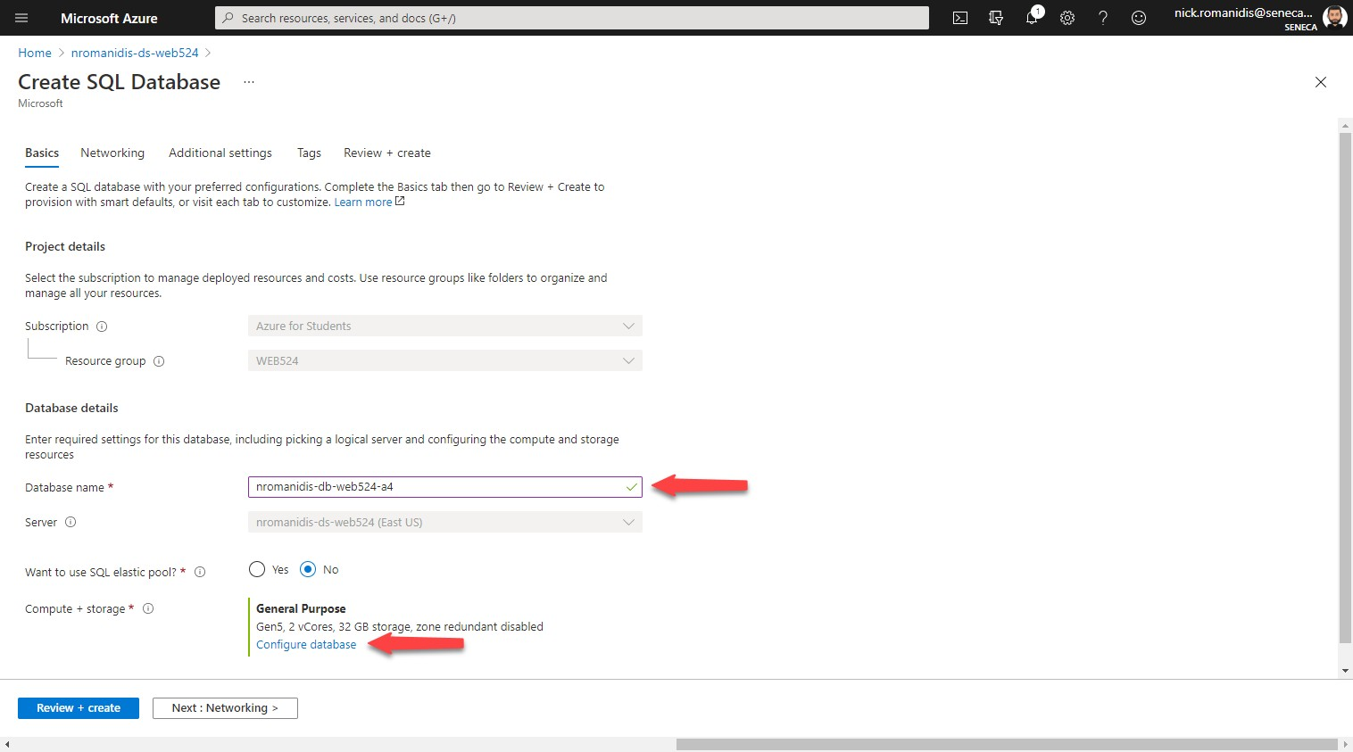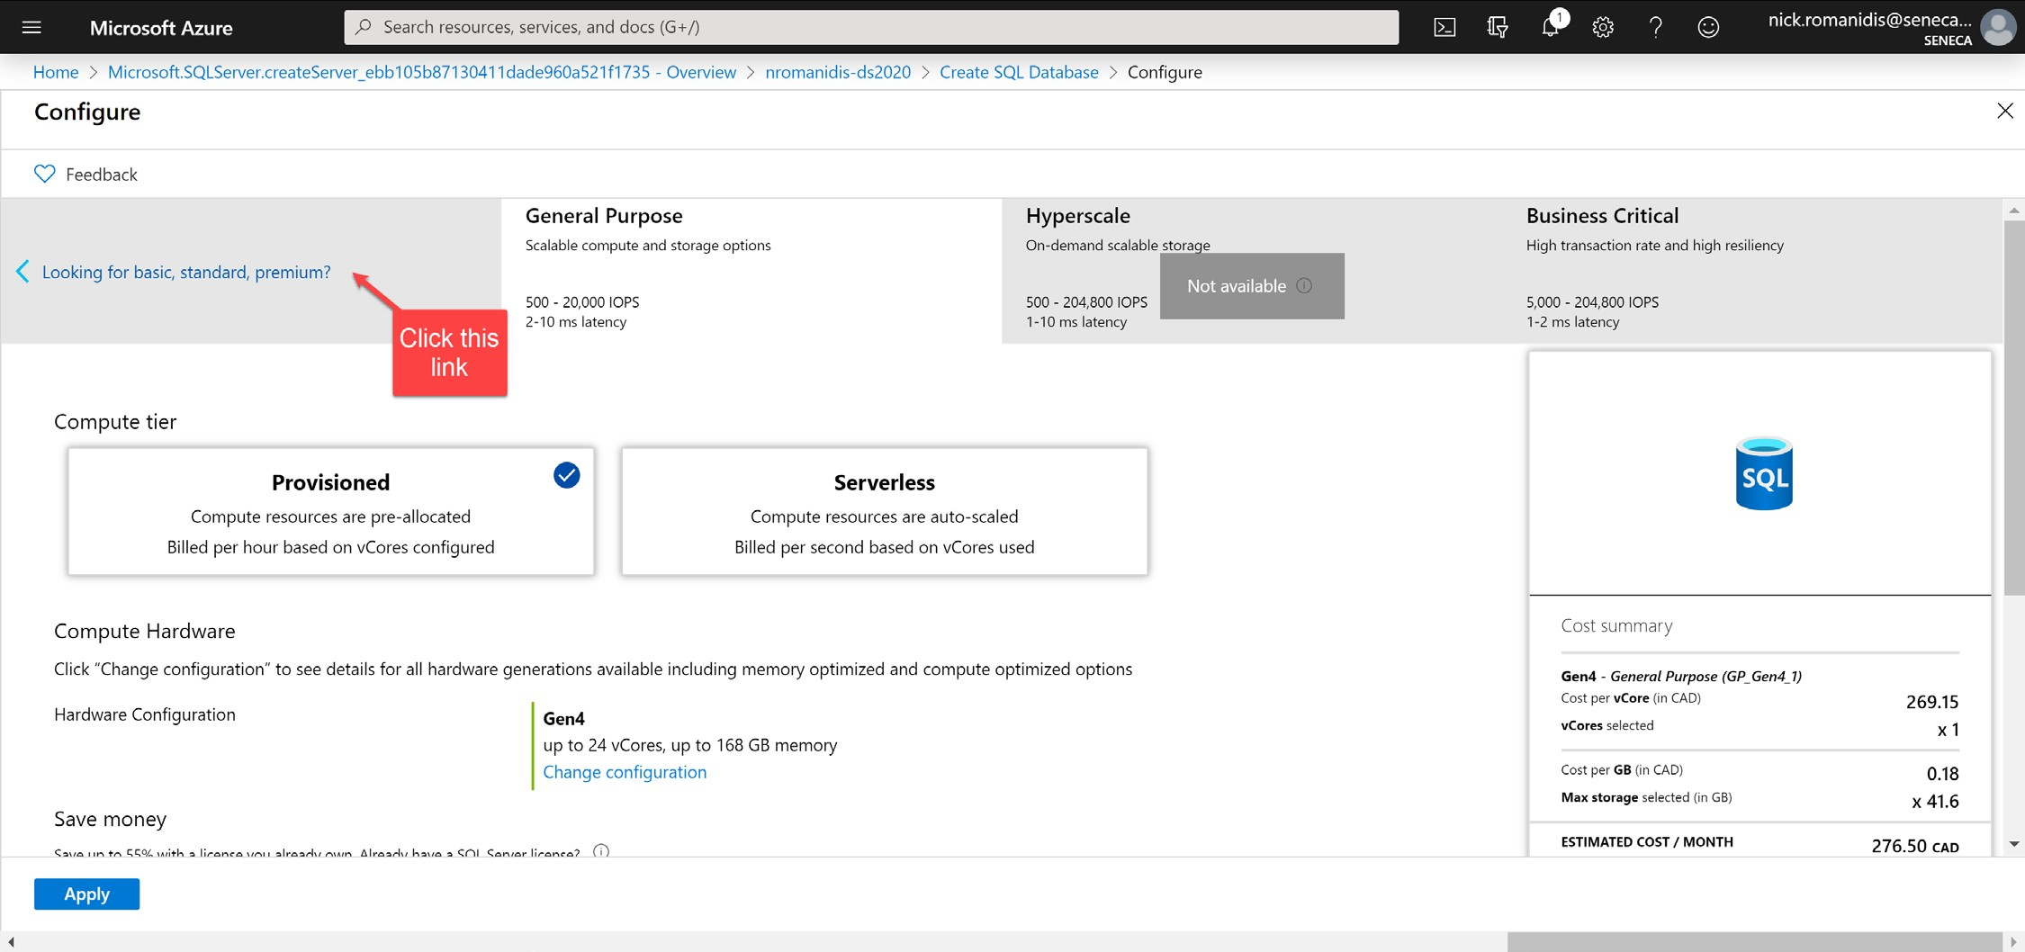

Choose the **Basic** package then click **Apply**.

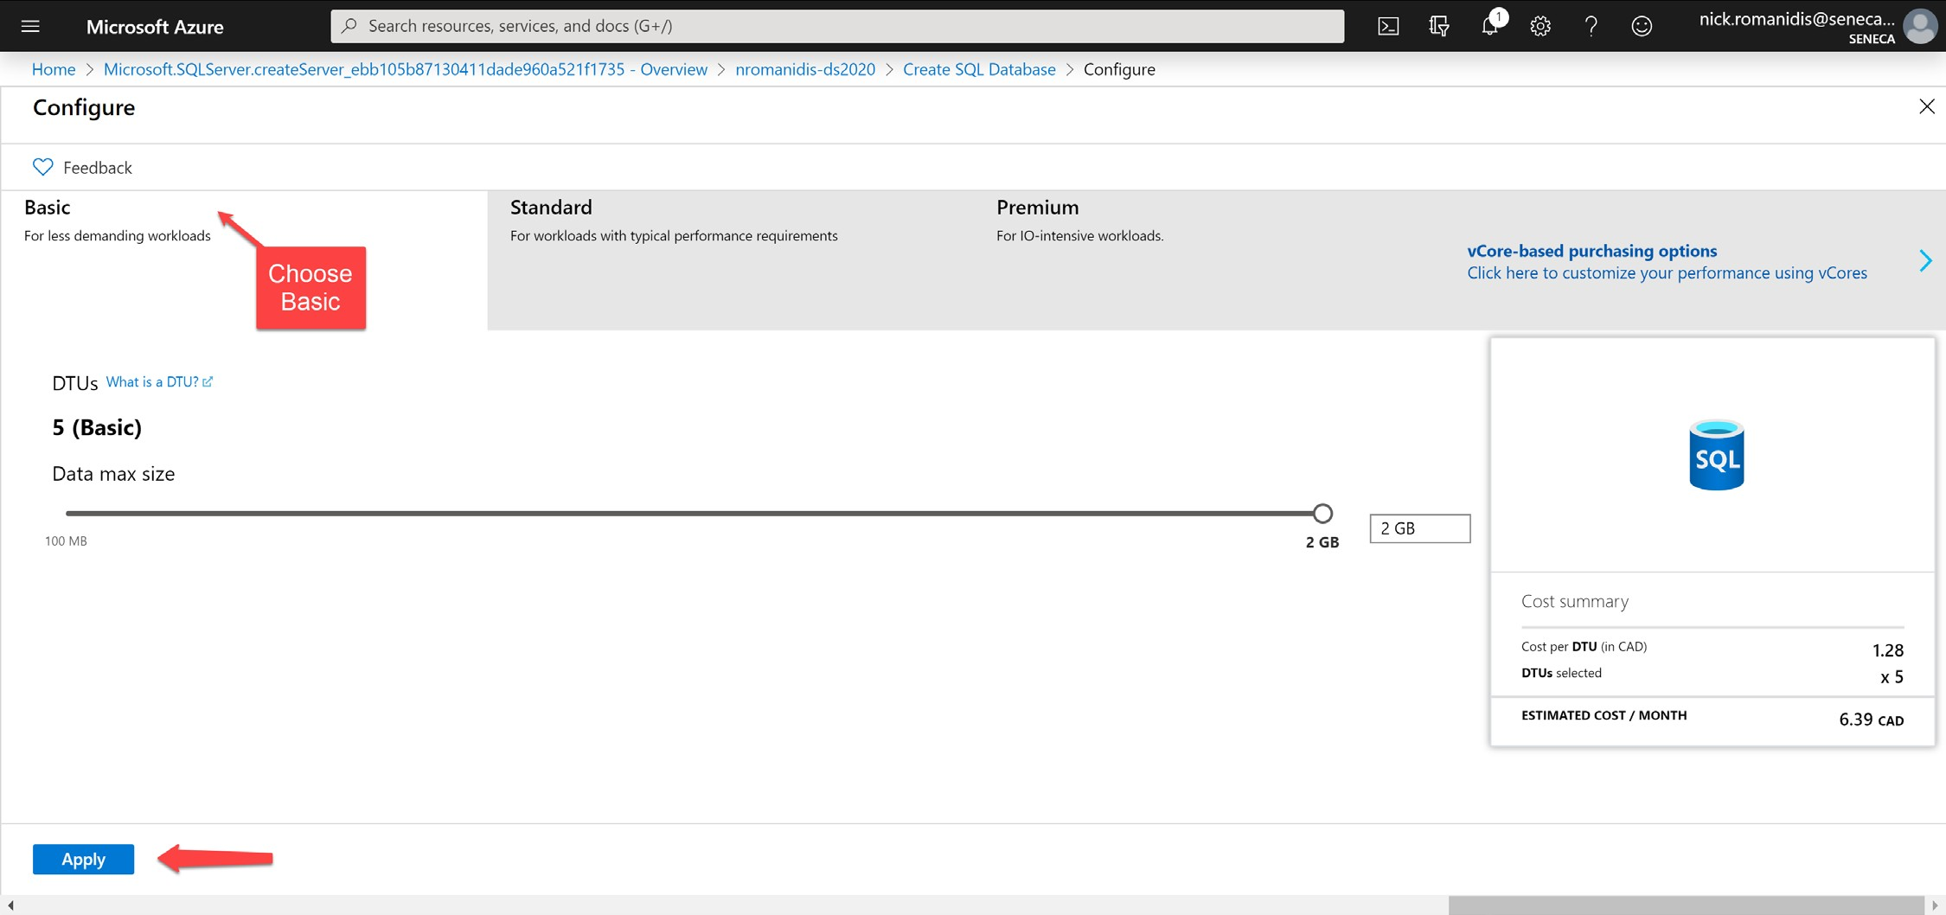

Click on **Review + Create**. If everything looks correct you can click **Create** to deploy the new database.

**Notice:** You will see a charge of about $6/mn to deploy the database. You have already received a $100 credit with Azure so you don’t have to pay for this. Plus, you will not have a credit card on file any way.

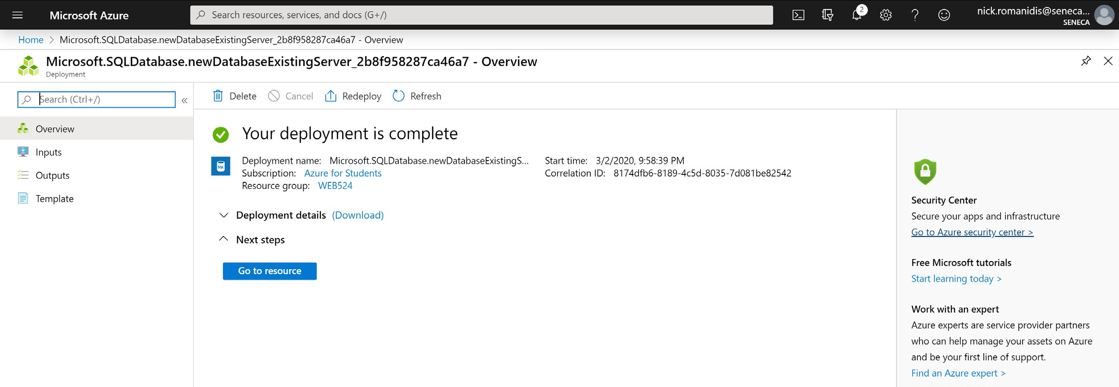

You can review the resources you have deployed by clicking on “All resources” under the hamburger menu in the top- left corner.

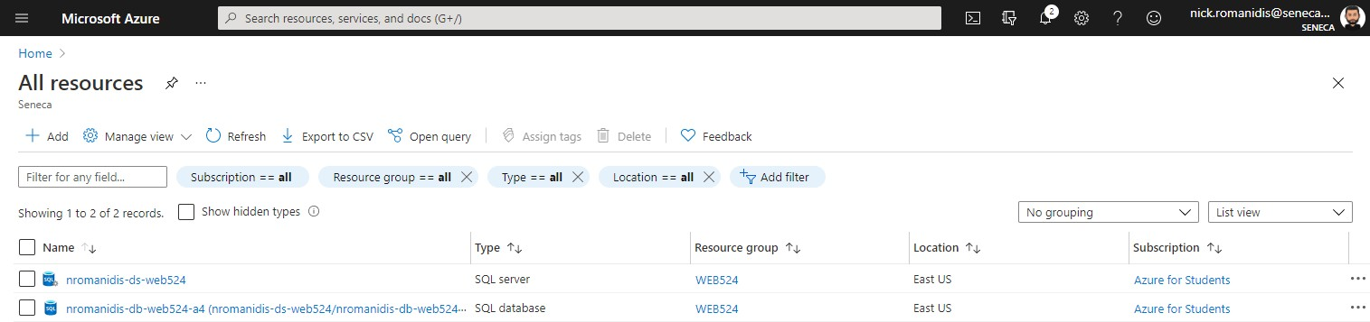

## Create a web app

The following procedure will enable you to create the web app for your assignment. In the Azure portal, choose

**+ Create a resource** (this option is contained in the hamburger menu). Choose **Web App**.

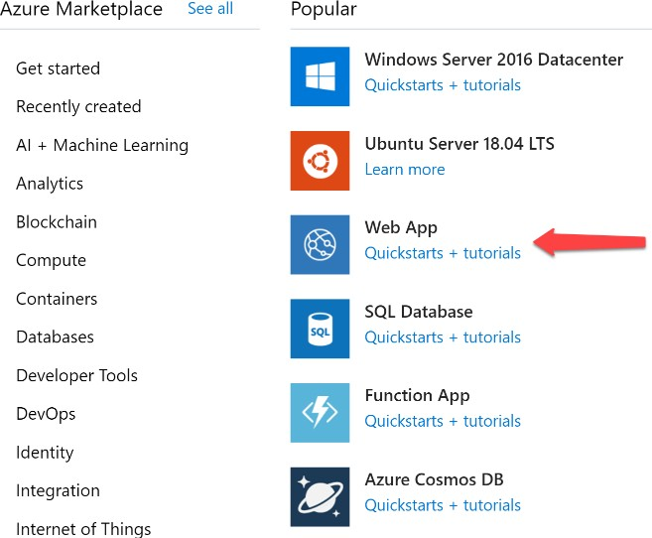

Fill in the information as shown below. Do not forget to replace “nromanidis” with your Seneca ID.

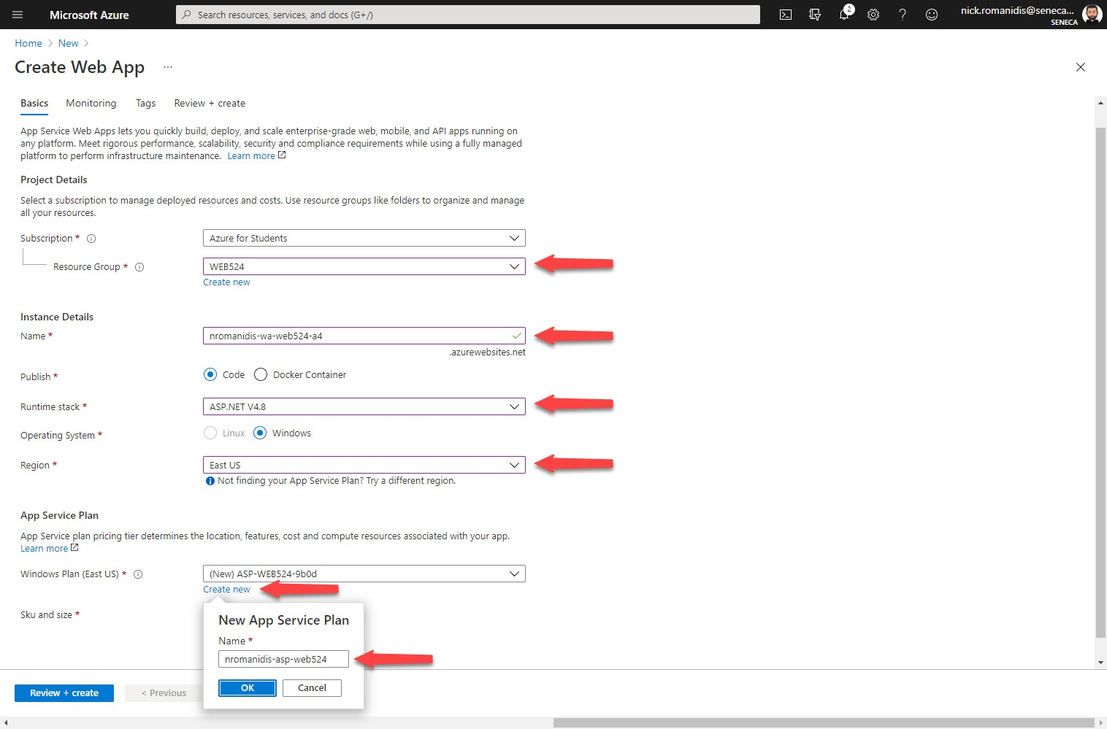

Verify that you are using the Free SKU. When you’re ready, click on **Review + create**. Confirm the details are correct then click **Create** to deploy the web app.

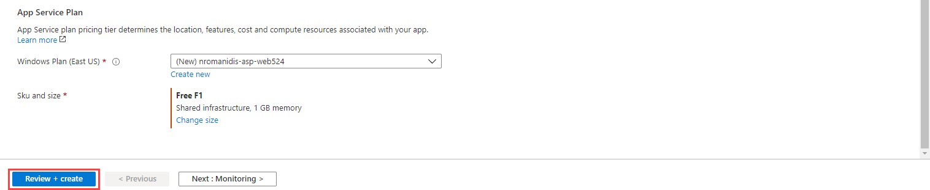

When deployment has finished. Click on **All resources** on the sidebar and review your different deployments.

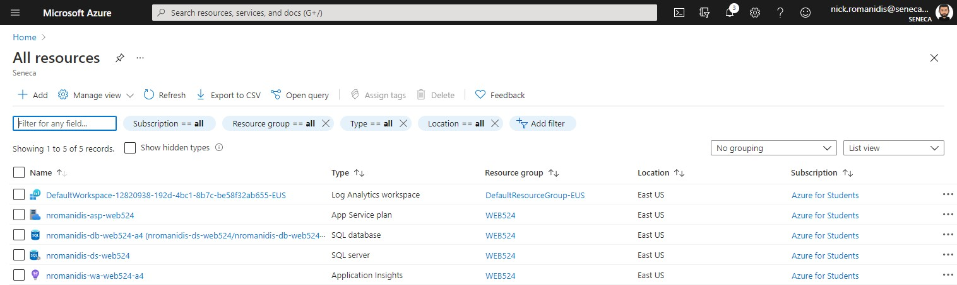

# Publish (deploy) your web app and SQL Database to Azure

Before you leave the Azure portal, you will need a database “connection string”. On the Azure dashboard, select your SQL Database item (e.g. nromanidis-db-web524-a4). A settings panel opens, click **Show database connection strings**.

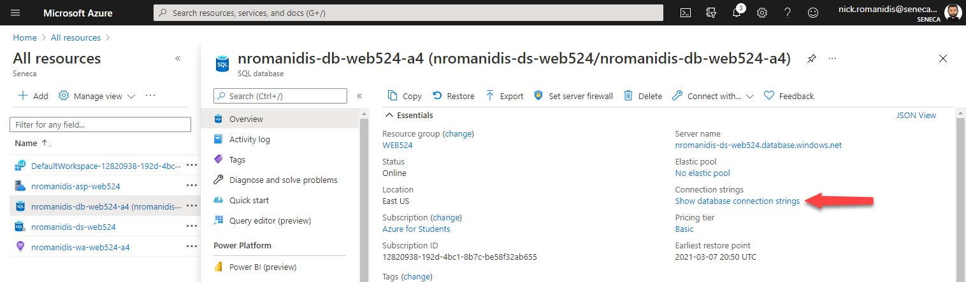

You will see the ADO.NET connection string.

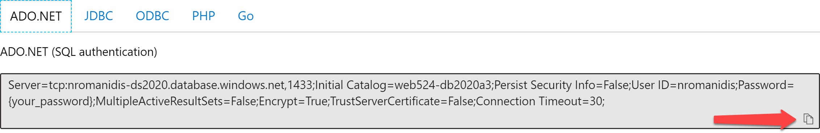

Later on, you will paste it into the Visual Studio “Publish” dialog. If you click the icon in the bottom-left corner, you can copy the string to your clipboard. Paste the connection string into a program like Notepad, then change the

{your_password} part including the curly brackets { } to your own database “Server admin login” and it’s password. For example:

…=False;User ID=nromanidis;Password={your_password};MultipleActiveR…

Becomes:

…=False;User ID=nromanidis;Password=Password123!;MultipleActiveRsultSets…

# Allow Azure Services Access

Back in the Azure Portal, click on the server name to access your SQL Server settings.

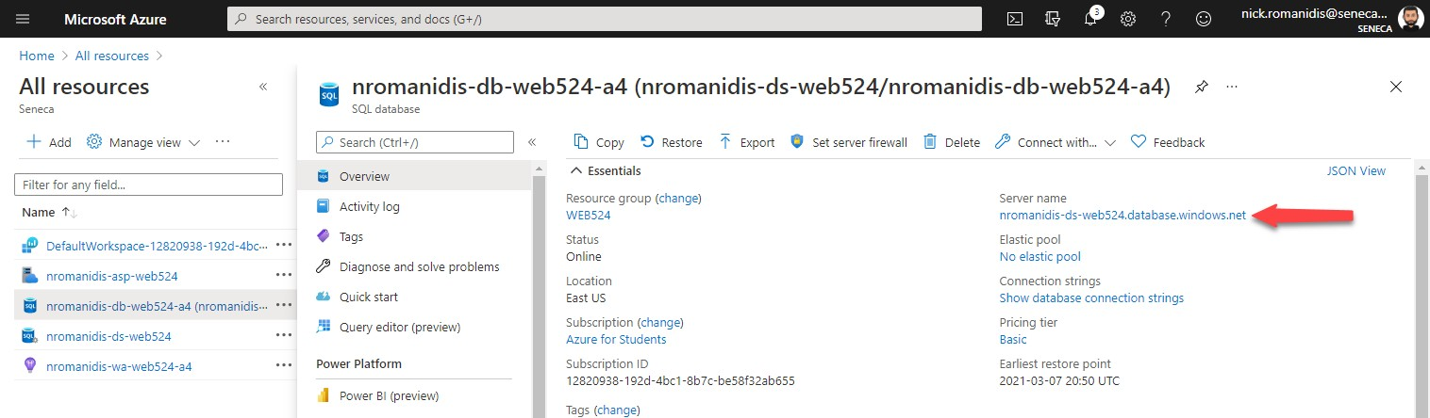

Click on **Show firewall settings**. In some versions of the dashboard, this may show as “Networking: Show Networking Settings”.

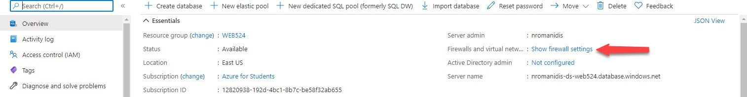

Turn on **Allow Azure services and resources to access this server**.

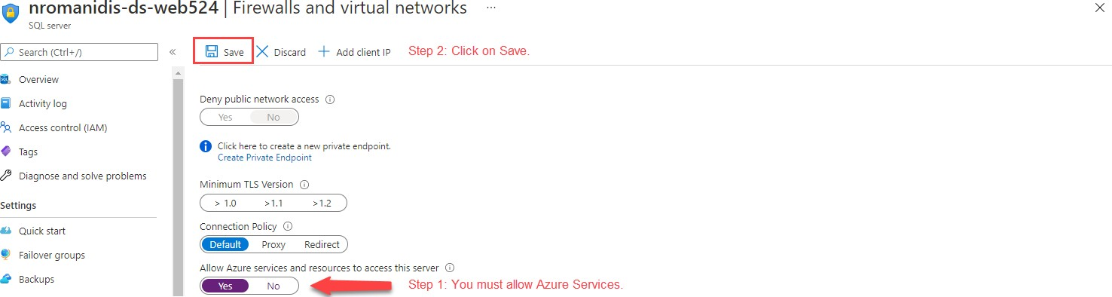

# Creating an ASP.NET MVC web app with security

Open an instance of Visual Studio and create a new “ASP.NET Web Application (.Net Framework)” project and name it as follows: **your initials** + “**2237A4**”. For example, your professor would call the web app “*NKR*2237A4”.

Notes:

* You are **not** using “Web App Project Template V1” for this assignment.

### Make sure you choose MVC and the “Individual User Accounts” authentication scheme.

After creating the web app, customize the home page. **Change the “Learn more >>” button to “Assignment 4 on Azure” and set the button link to the URL of your web app on Azure.** If you do not specify a URL, your assignment cannot be marked, and you will receive a grade of zero.

For example, <https://nromanidis-wa-web524-a4.azurewebsites.net/>

Follow the guidance from Assignment 1 to customize the app’s appearance. Please feel free to delete or comment out the About and Contact pages. If you delete these pages, remember to remove the links from the header. **Don’t forget to customize the footer!**

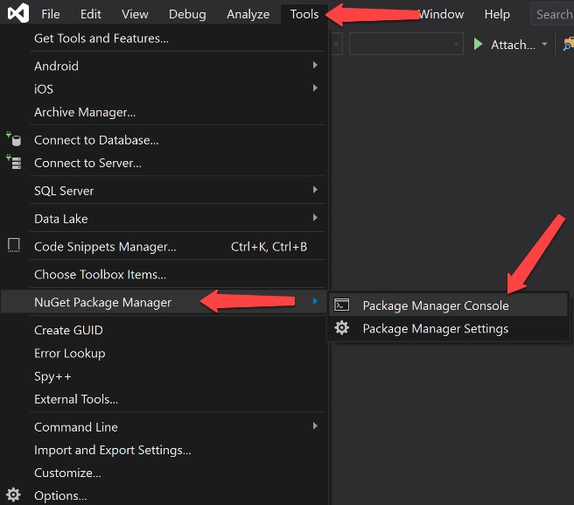Run the web app locally so that it will create the database files. This database will be deployed to Azure with the web app later on.

Enable (Code first) migrations in you project. Open the **Package Manager Console** in

Visual Studio, and type the following commands:

PM> enable-migrations PM> add-migration initial PM> update-database

The output should be similar to the following screenshot:

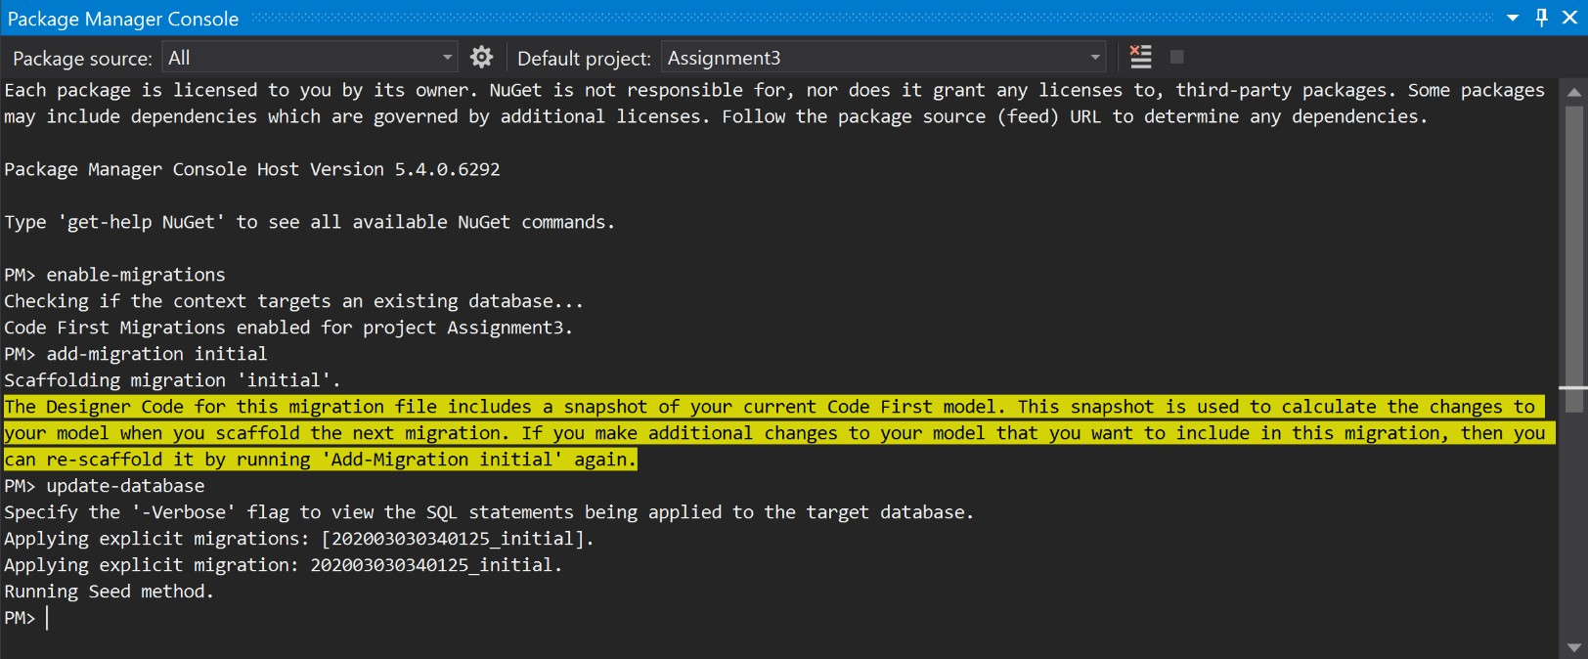

If you receive a **CommandNotFoundException** when trying to run the migration commands, you’ve most likely forgot to turn on **Individual User Accounts**. Close Visual Studio, delete your project, then recreate it again.

# Deploy the web app to Azure Platform

Make sure that the web app builds without errors and that it runs locally. Also ensure the web app has been configured with the Migrations feature. In the **Solution Explorer**, right-click your project item and choose **Publish**.

In the Publish screen, choose “Azure” then click “Next”.

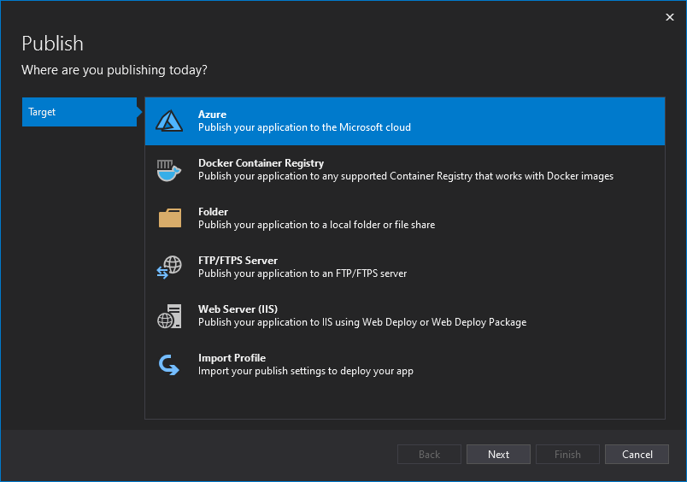

On the next screen, choose “Azure App Service (Windows)”. Click “Next”

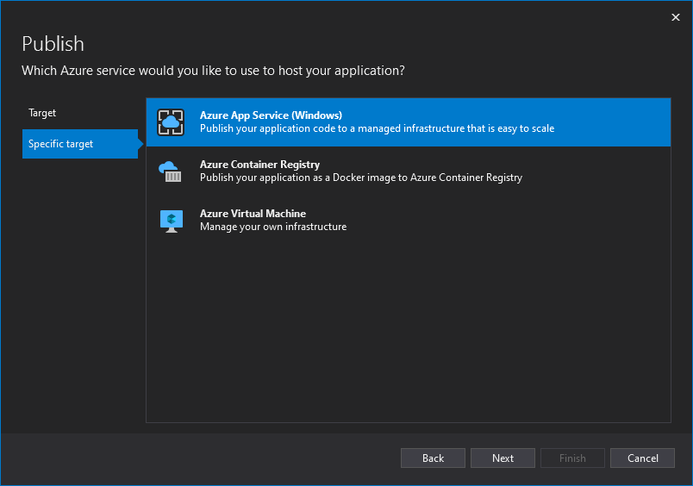

On the next screen, ensure your Seneca account appears in the top-right corner. If not, you must log in to your Seneca account. Choose the subscription you made and then find the web app created earlier. Click “Finish”.

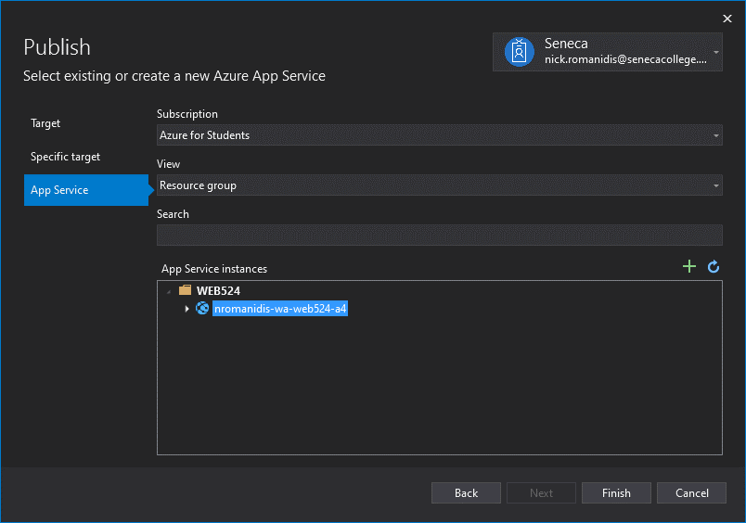

You are now returned to Visual Studio. Click on **Edit**.

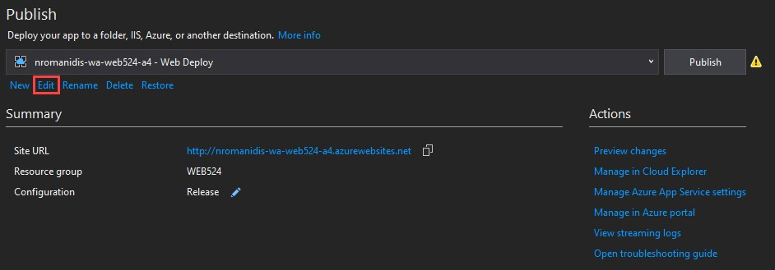

A dialog will appear, click the **Settings** button.

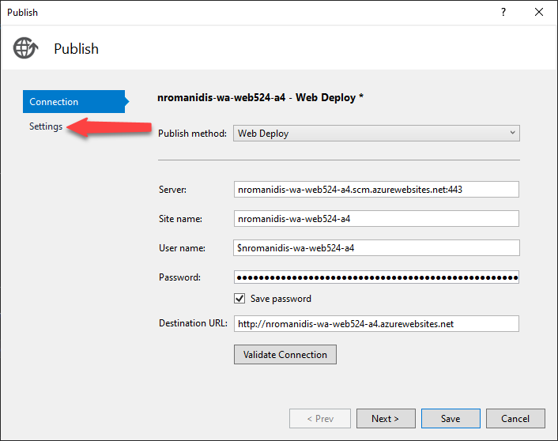

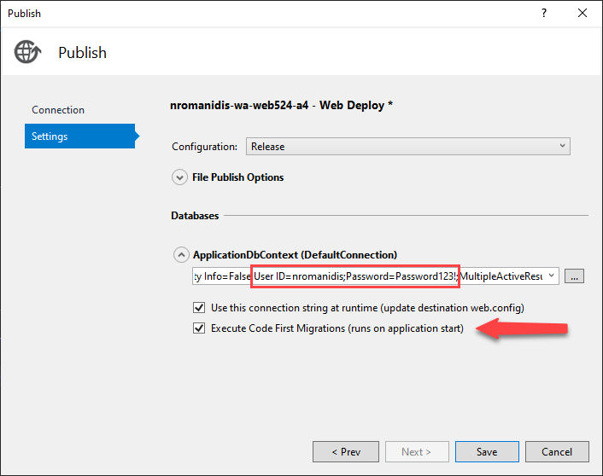

Place a check in the checkbox labelled **Execute Code First Migrations…**

Now, paste the connection string that you copied from the Azure portal into the “DefaultConnection” box. Make sure you have updated your password (and user id if necessary). Click **Save**.

Again, you are returned to Visual Studio. Click the **Publish** button to deploy your website.

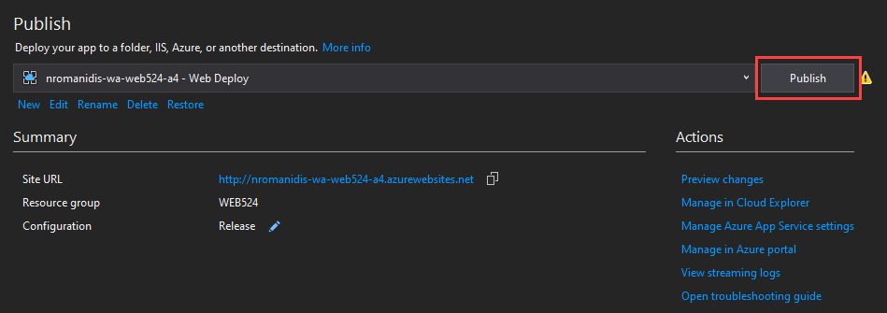

Visual Studio will copy the web app and SQL Database definition to Azure. When it is done, it will open the hosted web app in your default browser.

This publish task will NOT copy data from your local computer’s database, to the Azure database. Therefore, in your future assignments, you will need to initialize and/or load data to servers after the projects are deployed.

# Testing your work

Test the pages of your assignment 4 on Azure to see if the web app is successfully deployed. In addition, you should try to register a user and log in that user using the web app. This will ensure the database server works and has been configured correctly.

**Reminder:** The “Learn more >>” button on the project home page must be customized to link to your “Assignment 4 on Azure” in the cloud. Your professor will use this link to test and mark your assignment.

# Reminder about academic integrity

You must comply with [Seneca College’s Academic Integrity Policy.](https://www.senecacollege.ca/about/policies/academic-integrity-policy.html) Although you may interact and collaborate with others, this assignment must be worked on individually and you must submit your own work.

You are responsible to ensure that your solution, or any part of it, is not duplicated by another student. If you choose to push your source code to a source control repository, such as GIT, ensure that you have made that repository private.

A suspected violation will be filed with the Academic Integrity Committee and may result in a grade of zero on this assignment or a failing grade in this course.

# Submitting your work

### Before submitting your assignment, remember to update the home page link so that it points to the project you deployed on MS Azure. Your site will be marked using MS Azure so make sure to test on the cloud as well as locally!

Make sure you submit your assignment before the due date and time. It will take a few minutes to package up your project so make sure you give yourself a bit of time to submit the assignment.

The solution folder contains extra items that will make submission larger. The following steps will help you “clean up” unnecessary files. Please make sure you clean up the project before submitting to prevent issues with Blackboard.

1. Locate the folder that holds your solution files. You can jump to the folder using the Solution Explorer. Right- click the “Solution” item and choose “Open Folder in File Explorer”.
2. Go up one level and you will see your solution folder (similar to **NKR2241A4** but using your initials). Make a copy of your solution and change into the folder where you copied the files. For the remainder of the steps, you should be working in your copied solution!
3. Delete the “packages” folder and all its contents.
4. In the project folder (should be called **NKR2241A4** but using your initials) contained within the solution folder, delete the “bin” and “obj” folders.
5. Compress the copied folder into a **zip** file. **Do not use 7z, RAR, or other compression algorithms (otherwise your assignment will not be marked).** The zip file should not exceed a couple of megabytes in size. If the zip file is larger than a couple of megabytes, do not submit the assignment! Please ensure you have completed all the steps correctly.
6. Login to [https://learn.senecapolytechnic.ca/.](https://learn.senecapolytechnic.ca/)
7. Open the “Web Programming Using ASP.NET” course area and click the “Assignments” link. Follow the link for this assignment.
8. Submit/upload your zip file. The page will accept unlimited submissions so you may re-upload the project if you need to make changes but make sure you make all your changes before the due date. Only the last submission will be marked.
9. It is highly recommended you download the submitted assignment and test it on your computer.